Data Structure:  
  
You cannot need to put each data ( symbol / letter / char ) in different variables all the time, sometime you want to group them based on type or other things, there is where data structure comes in… i.e way to organise data..  
  
DataStructure – organise, store and access of data



In programming –based on value, similar data is identified and named it as different types called data types.  
  
Data type – attribute of data that describes the value it have and how it has to be used

Each data is stored in binary, each data type maintains them based on exact bits they are made to allocate with how precision… so specific value stored doesnot affect its size, it primitive data type defines its size allocated memory… For non primitive, value stored affects its size, but in some programmatical manner of working things innerhood.

Numerical data types – differs based on its precision to store each values .. high precision , large size… ( changes based on different prog lang )..

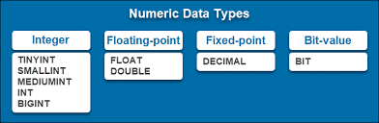

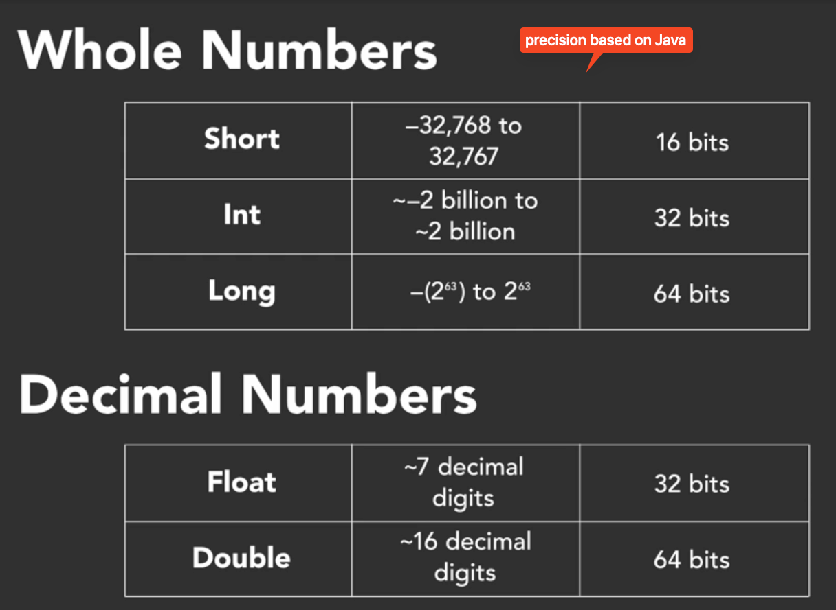

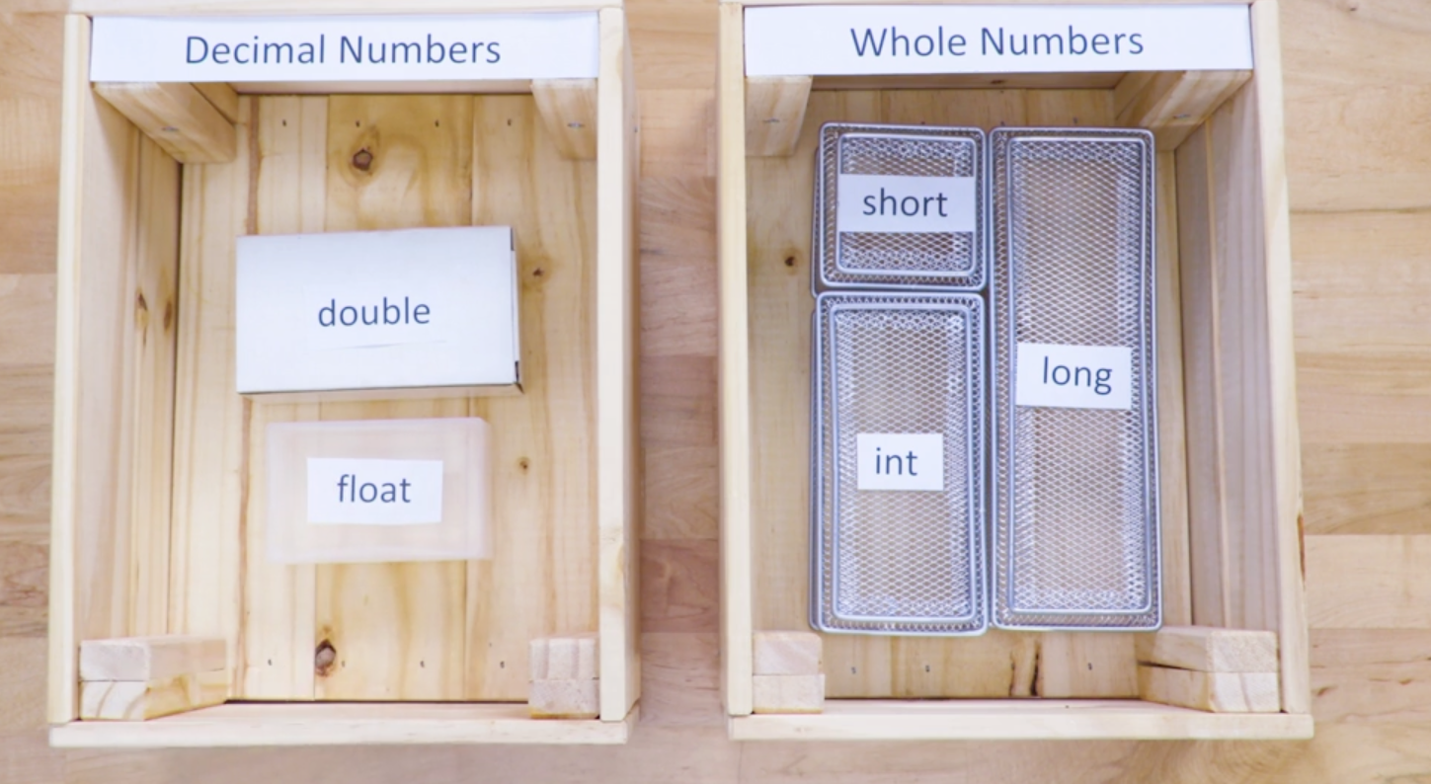

In java, default double for decimal point numbers and int for non-decimal numbers

Double in csharp and java always 64bits…

* Numbers further differed as signed (both +ve and -ve) and unsigned ( only +ve) … since storage size bit is same, ranges differes, e.g -10 to 10 for signed means, 0 to 20 for unsigned…

Different lang:

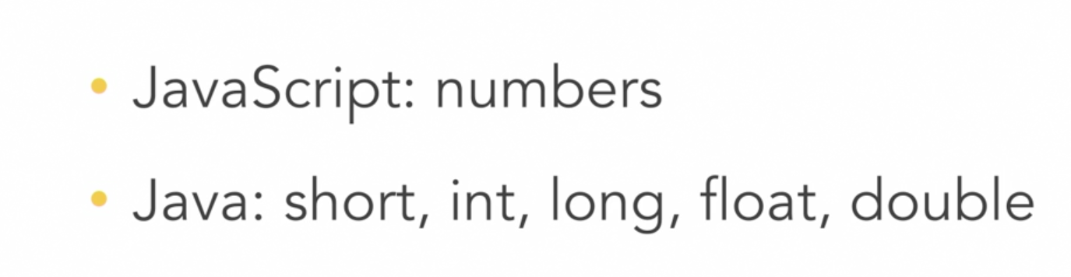

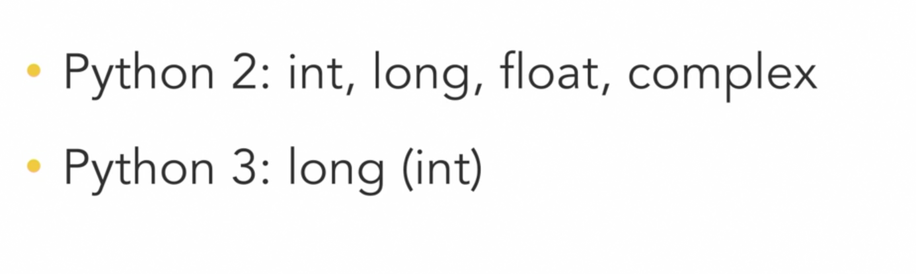

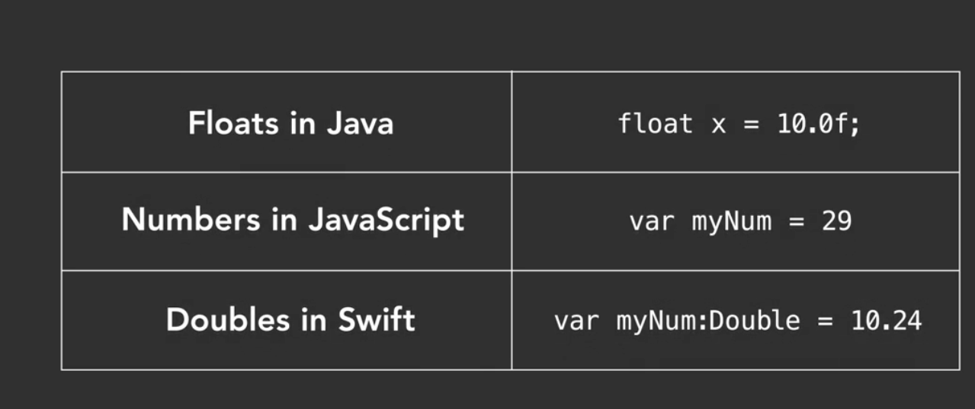

Boolean :

* True or false – yes/no type things…

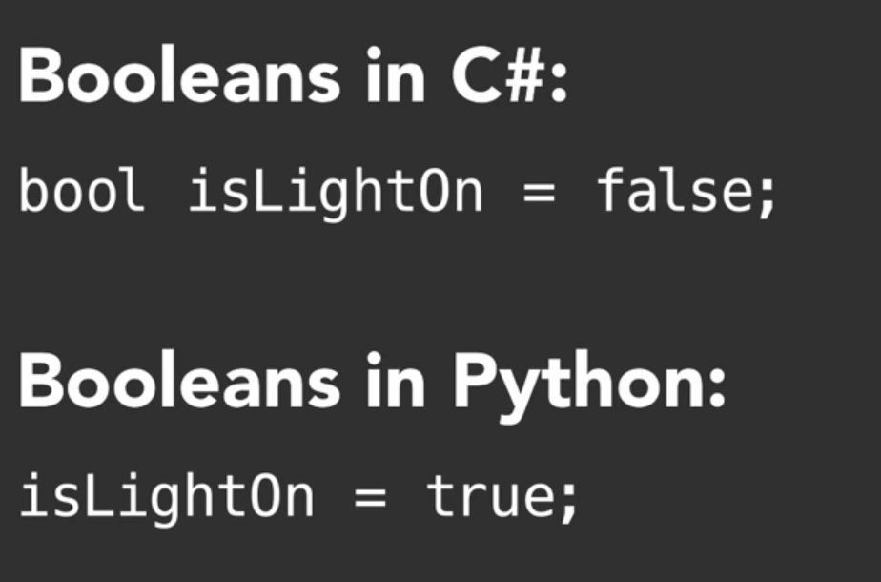

Char:

* Single letter to be stored
* Mostly wrapped single quotation ( py exception )

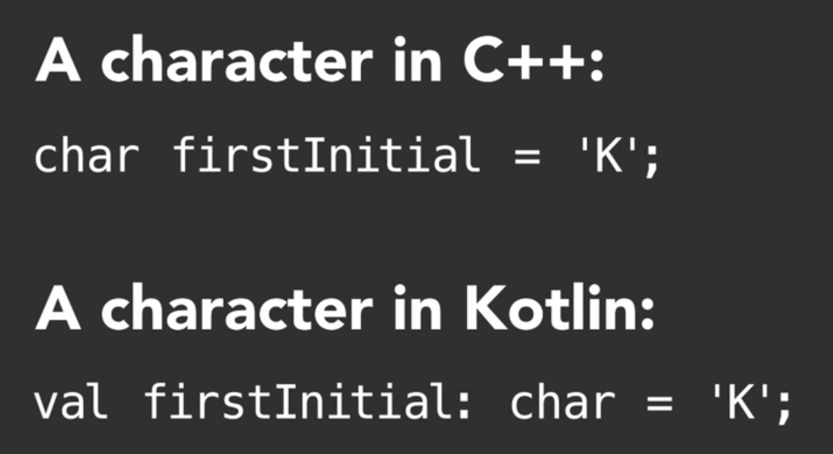

Cpp – 8 bits for char , where kotlin – 16bits

String:

* Sequence of chars
* Mostly wrapped in double quotations ( py exception )

Primitive type – basic/value types -> int, long, short, float , double, char ,Boolean…etc.. fixed size doesnot depend upon data inside it…

Maintain group of things that are in linking/similar in aspects have to grouped for to reduce complexity in understanding and maintenance both in real world and programming, so non-primitive datatypes come in.. this help in saving and doing things in efficient manner.

Non-primitive data types are types that build with help of other data types ( which at lower end uses primate data types )

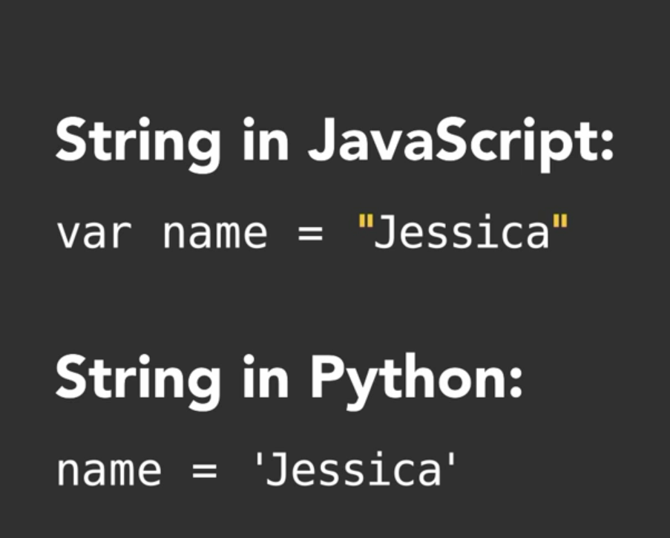

Py uses – single, double and triple quotations for char or string….

String – Data Structure that arranges and manages the sequence of char, basic char primitive data type and other things that manages the arrangements under hood…

For primitive data type – we know exact size of each independently, but non – primitive, it depends on things…

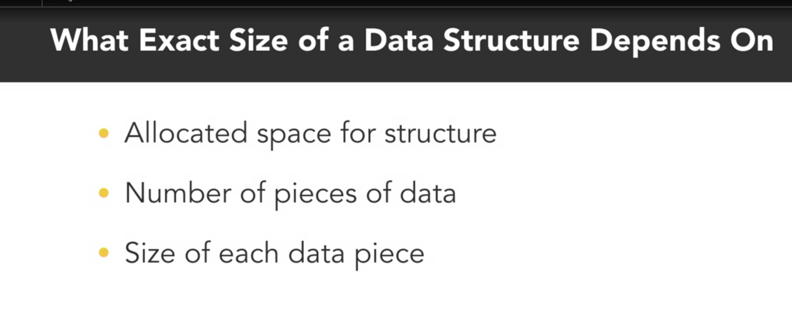

Primitive Data Types - we know the exact size of allocation for each, no matter of its specific value content… so can even find amount of space required even before allocating size for it…

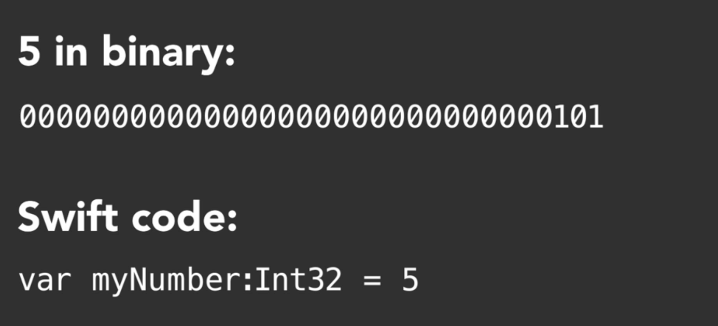

Data structure – size take up matters based on allocated, initialized and maintained…

We donot know how much data in data structures takes up.. since size changes based on item it contains and item content may changes and item counts may changes.. but may know the minimum item size but not exact …

[DS – Data Structures ]

When data of bits stored consecutively ,the risk of managing and overwriting data and may cause loose in precious data… so we solve this using pointers, i.e instead of storing the data consecutively, we store its address in which the item’s value is located..

So data structures data are stored as pointer which is the reference of item i.e address.. which are reference types..

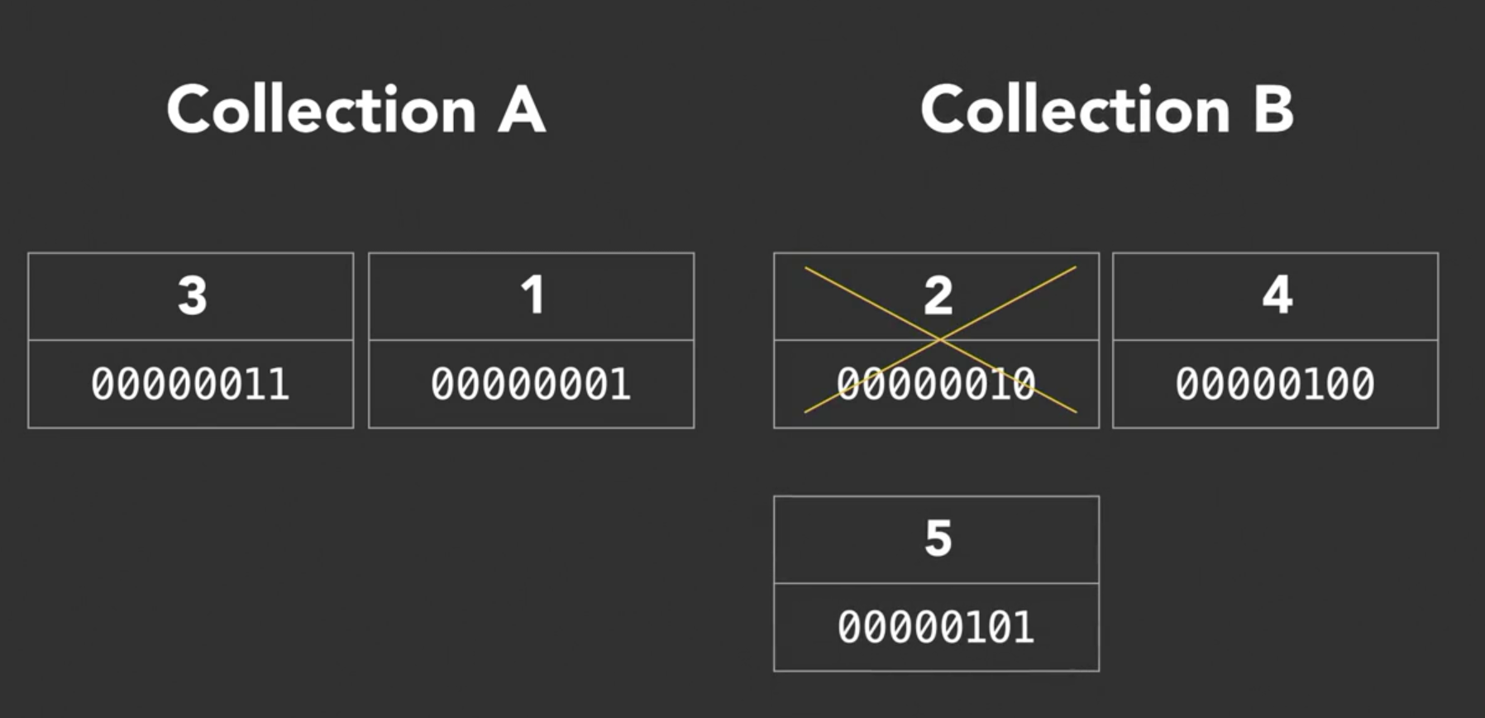

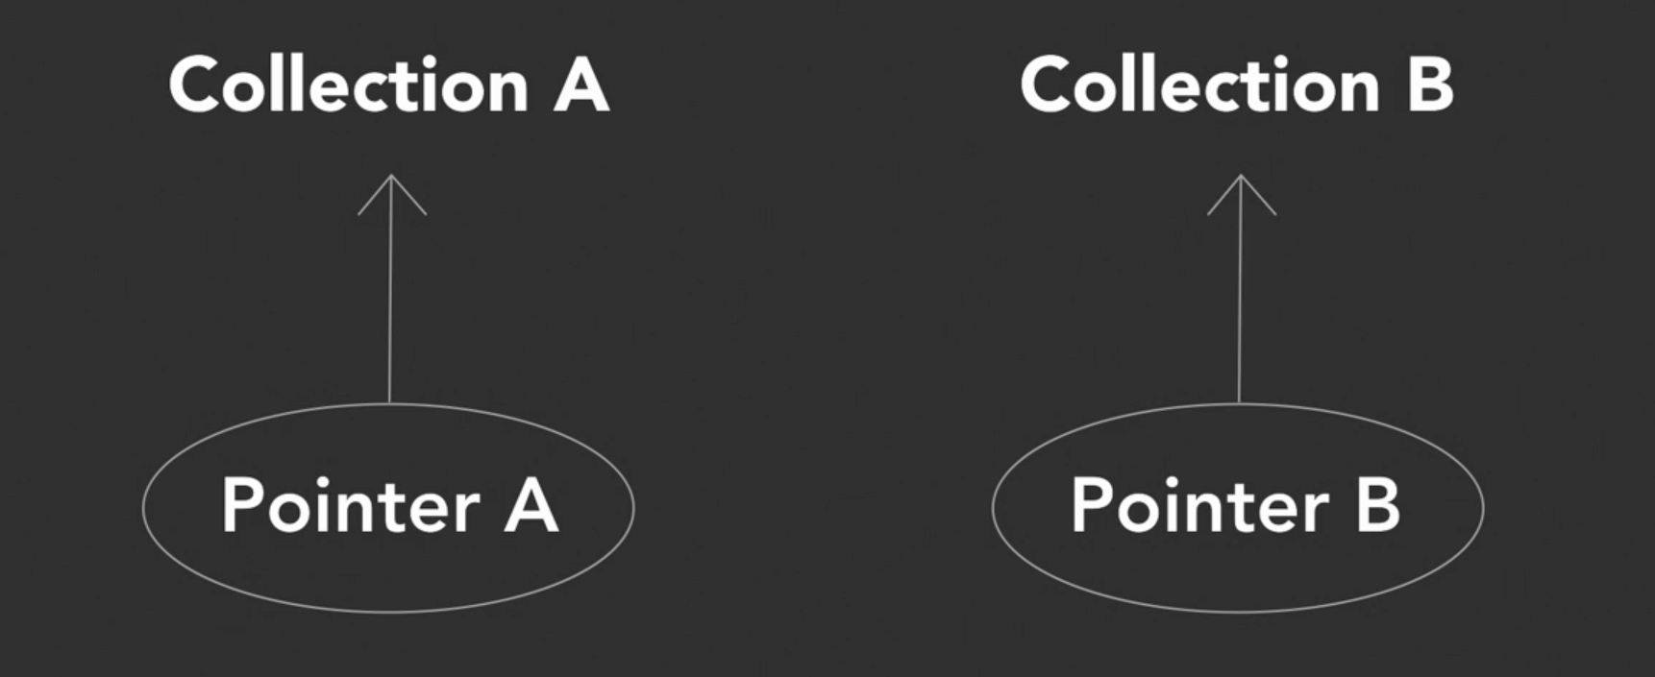

We also use term object to describe a value in memory referenced by an identifier.

Reference type – reference their specific value from an address of where the item is stored rather than direct access to the data itself… This means address changes, value represented by variable also changes. Reference types we are adding extra address layers, where primitive types we directly access the data stored…

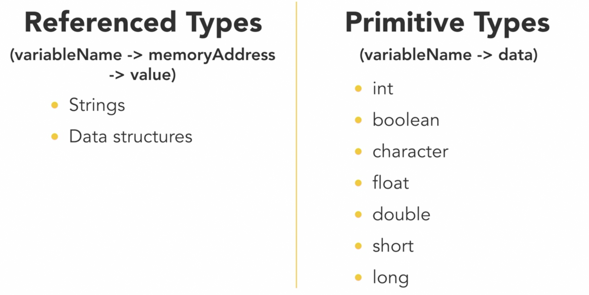  
  
These type of memory management is the foundation of DS.

Tools need to change pointers or access addresses are available based on programming languages.. usually its abstracted, so we just need to use programming lang syntax to do that..

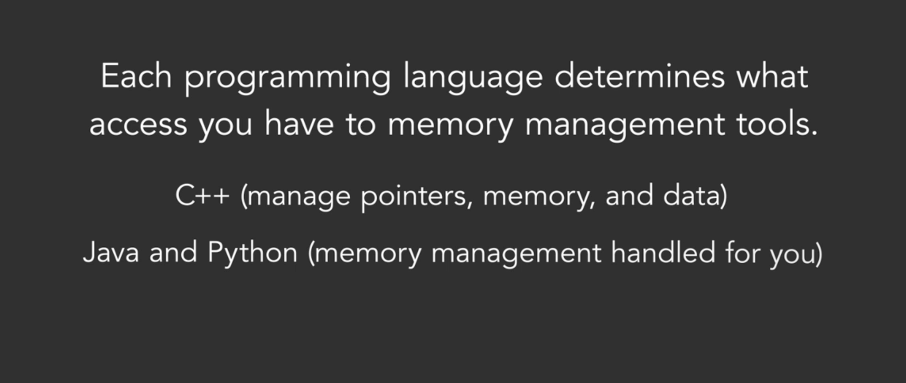

Data structure – A collection with defined way of accessing and storing items…

Arrays:

* Collection of items
* Each item identified by index or key

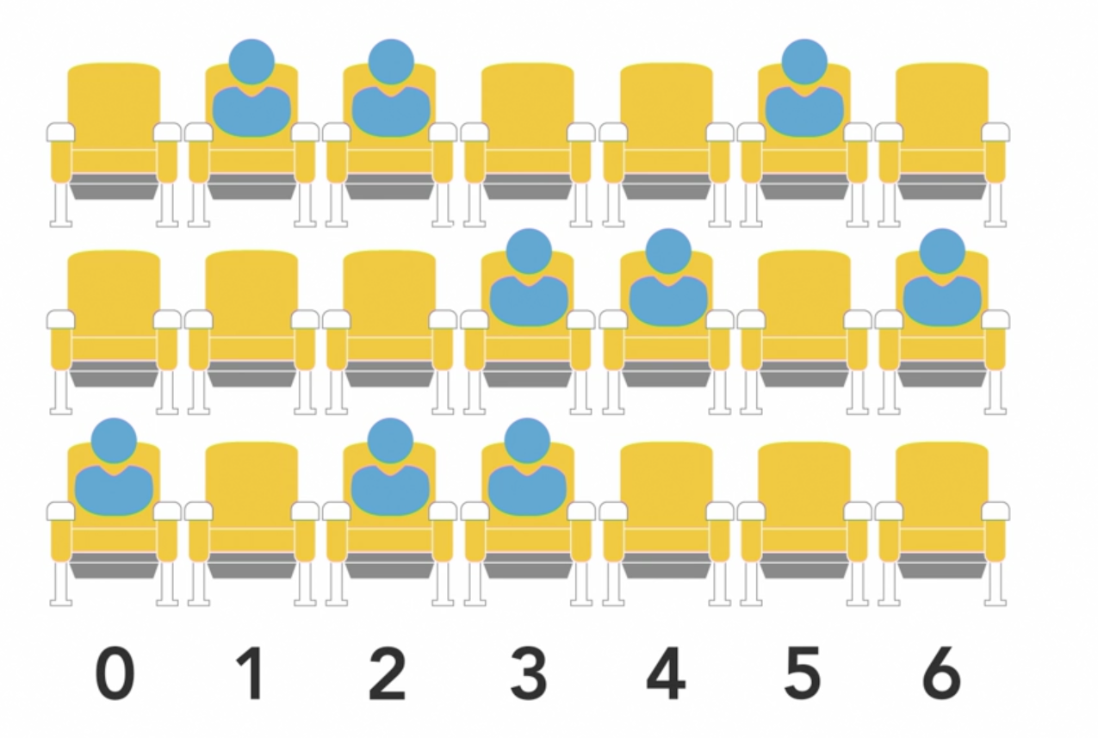

In theatre, like row of seats and each accessible by row number , array works like same…

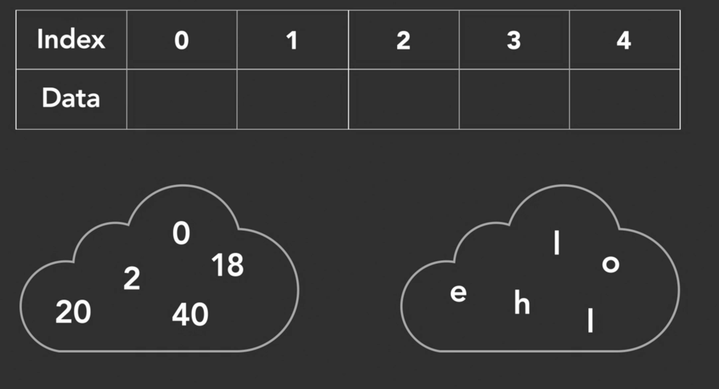

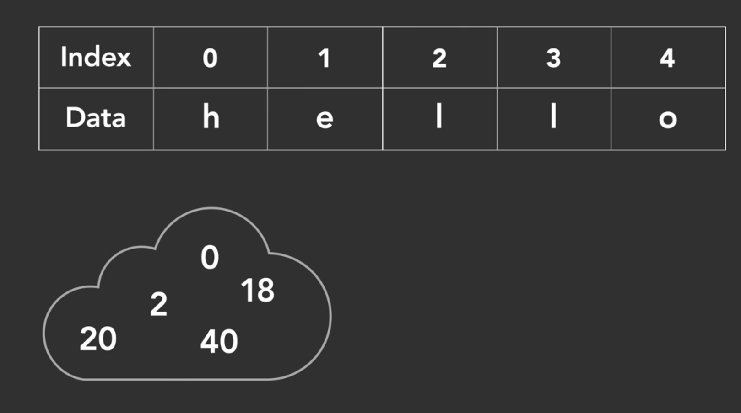

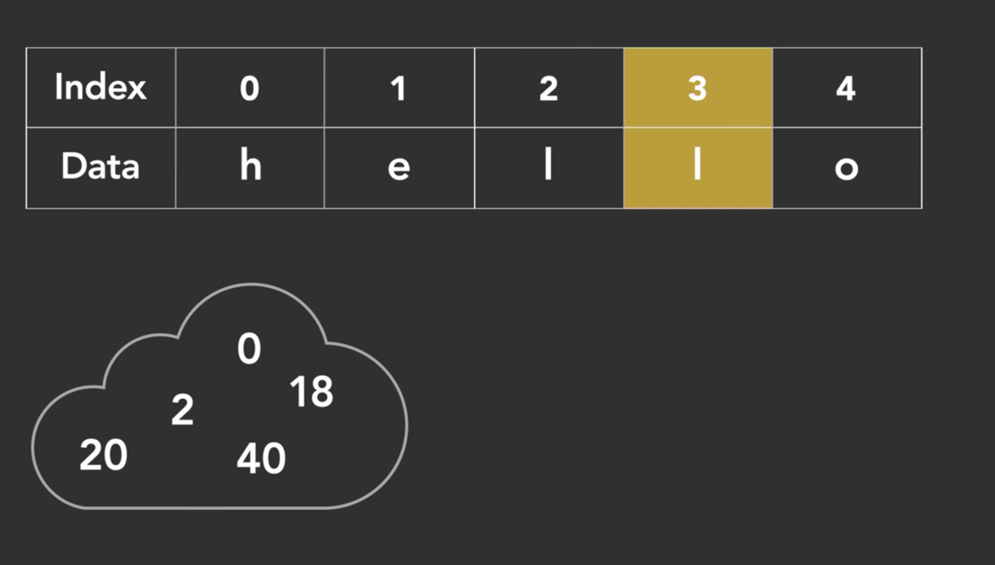

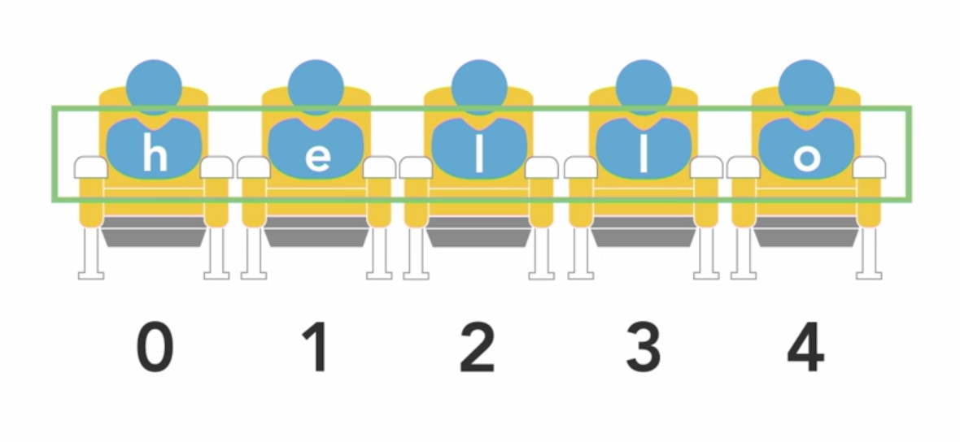

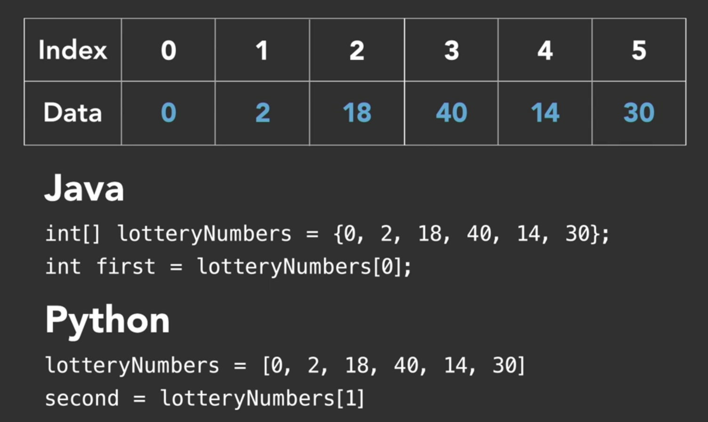

When you try to access index which is not present, it throw error..

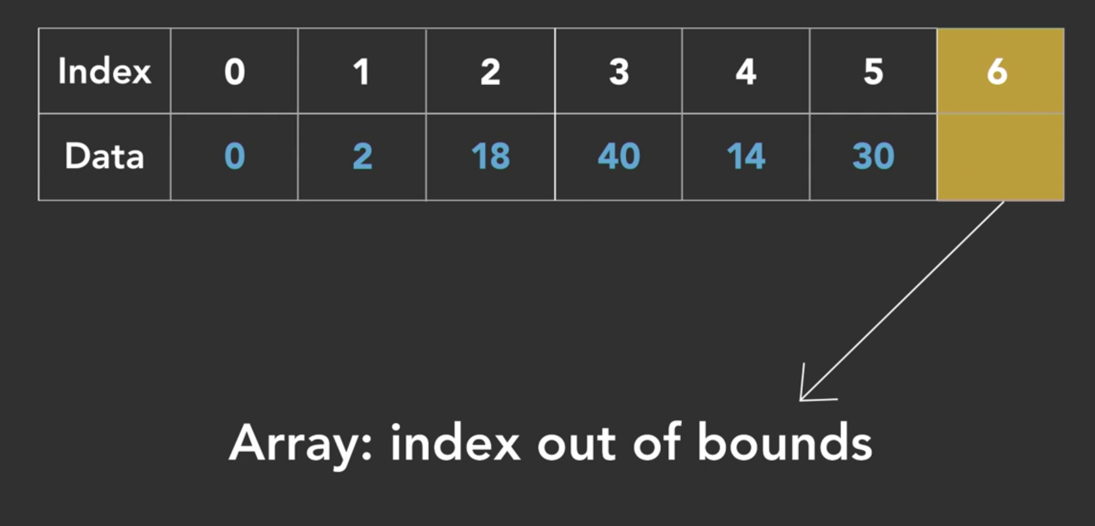

Arrays in swift:  
  
Finding average of pets that students have in class..

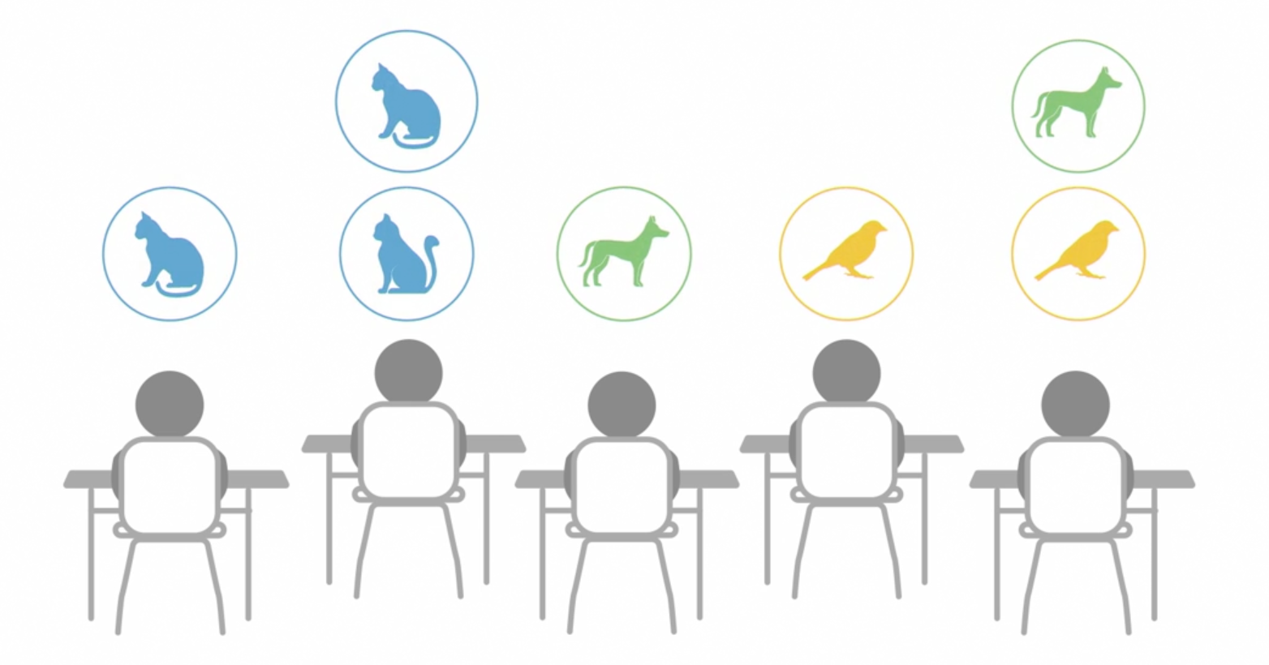

// swiftarrays.swift

// Average

var perStudentPetCount = [0, 1, 0, 2, 1, 1, 4, 0, 0, 0, 3, 2, 1, 3, 0, 2, 2, 4]

var numOfStudents = perStudentPetCount.count

// sumOfItems / numOfStudents

// print(perStudentPetCount[3]) //=> 2

// print(perStudentPetCount[100]) //=> Fatal Error: Index out of range

// print(numOfStudents) //=> 18

var sum = 0

for individualPetCount in perStudentPetCount {

sum = sum + individualPetCount

}

// print(sum)//=> 26

var average = sum / numOfStudents

// 26/18 = 1.44444444

// swift do integer division, so don't take decimals

print(average) //=> 1

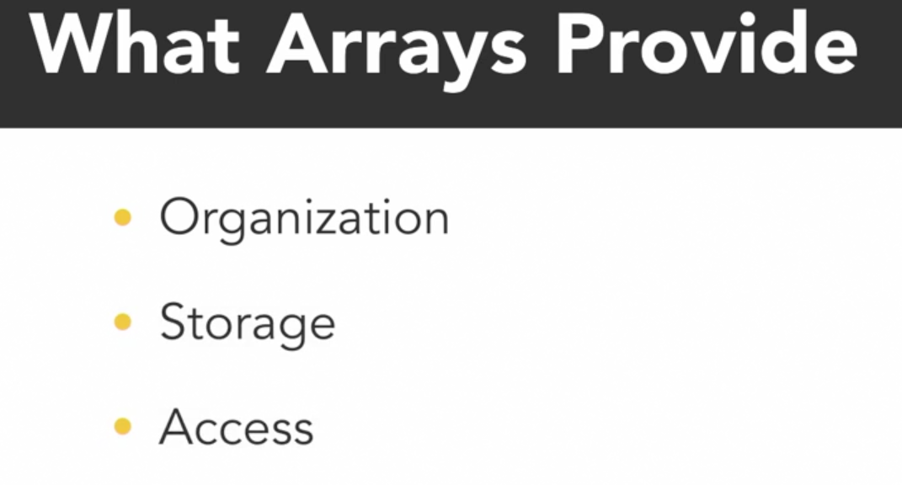

Multidimensional Array:

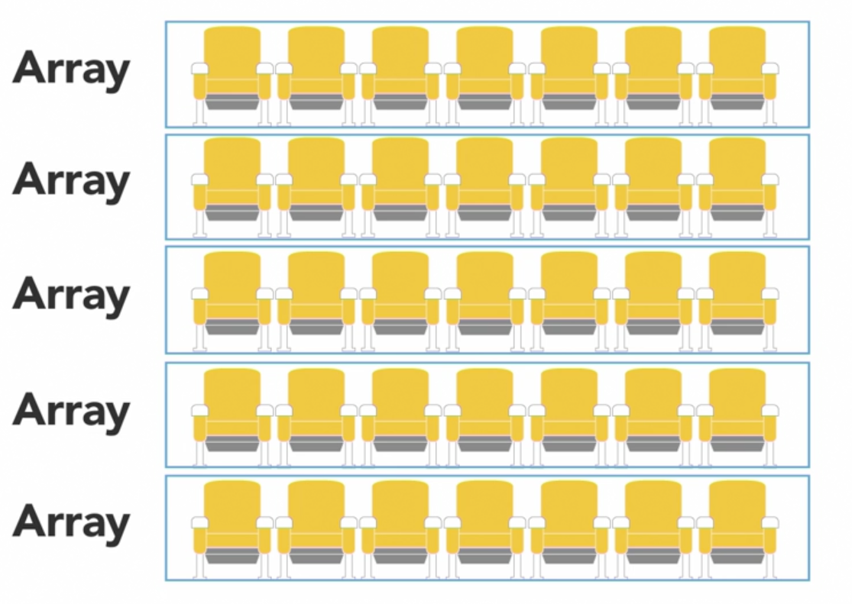

* Array of arrays is called multi dimensionl arrays… in which type of inner items and size of inner arrays are same here…

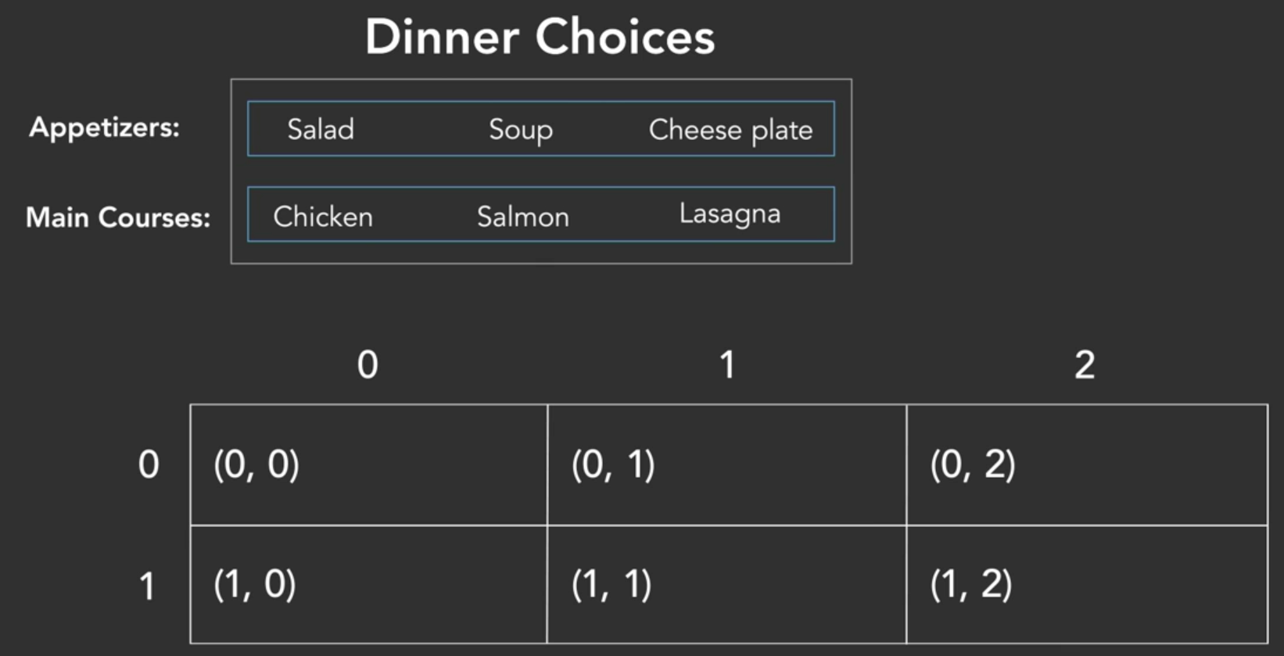

1st index – row

2nd index – column

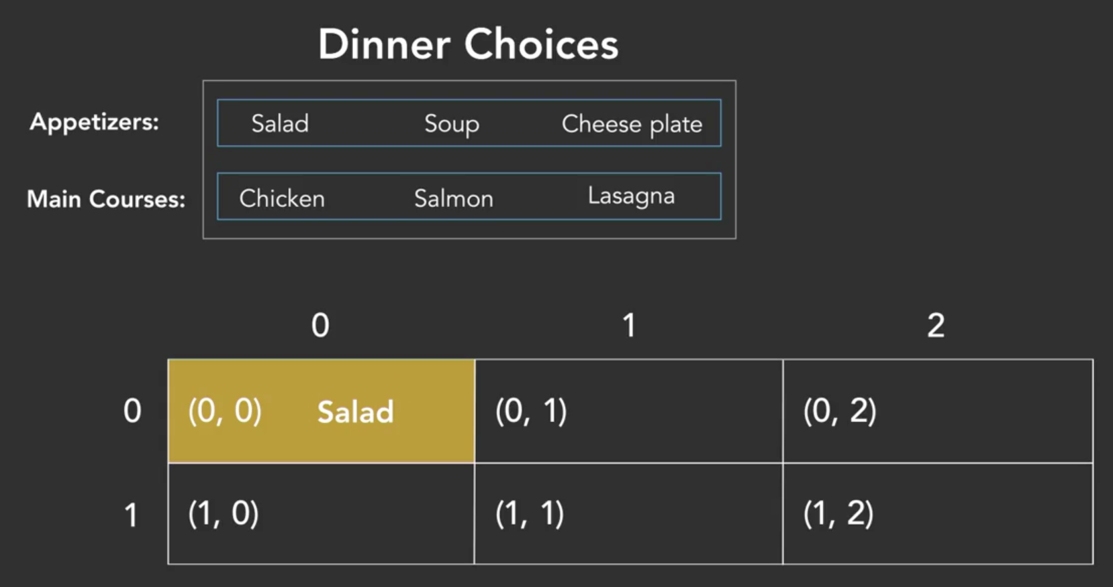

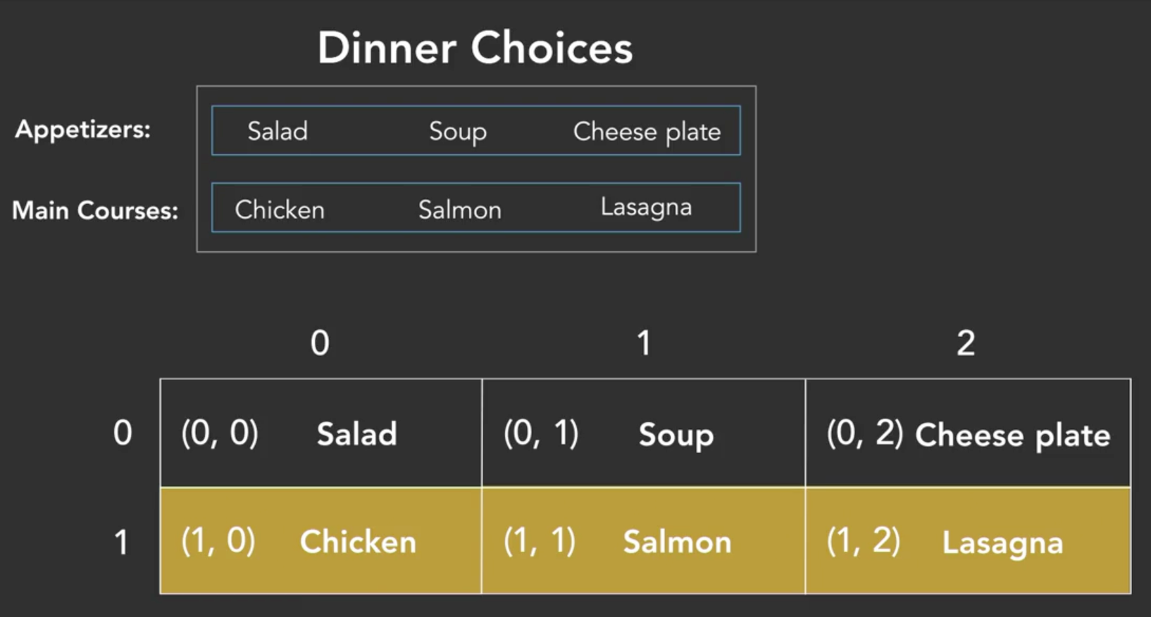

Number of rows = length of actual array

Number of columns = length of inner arrays ( same length )

Why arrays ? – sometimes we need to iterate through the entire array , those values comes in handy while using for-loops..

// javascriptmultiarrays.js

var dinnerChoices = [["Salad", "Soup", "Cheese Plate"], ["Chicken", "Salmon", "Lasagna"]]

let appIndex = 0

let mainDishIndex = 1

let firstApp = dinnerChoices[appIndex][0]

let secondApp = dinnerChoices[appIndex][1]

let thirdMainDish = dinnerChoices[appIndex][2]

console.log(firstApp)

console.log(secondApp)

console.log(thirdMainDish)

dinnerChoices[mainDishIndex][0] = "Steak"

console.log(dinnerChoices[mainDishIndex][0])

console.log(dinnerChoices)

/* =>

Salad

Soup

Cheese Plate

Steak

[

[ 'Salad', 'Soup', 'Cheese Plate' ],

[ 'Steak', 'Salmon', 'Lasagna' ]

]

*/

Jagged arrays:

* Can have elements of different dimensions and sizes
* Inner arrays length is not fixed – so no.of columns is not fixed…
* Iteration – needs access the length of each individual inner arrays..

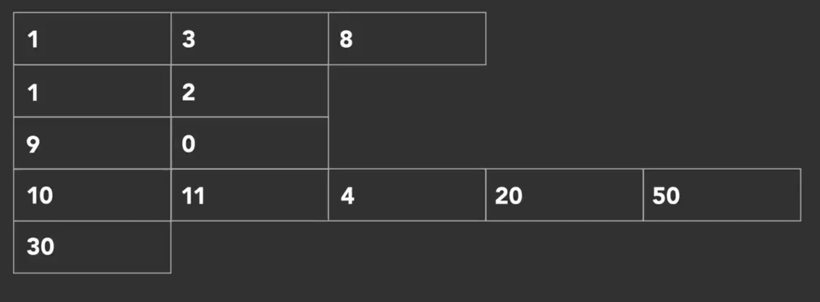

Why jagged:

* Data comes in various shapes , sometimes its uneven, if we use 2d array in these place, then potential waste of memory will be since of unused spaces..
* Jagged array can be optimized at intermediate language level and this can be exploited to speed up programs.
* C# natively differs jagged and multi dimensional array, but many other lang. don’t , so you need to create custom enumerator or own iterations in order to use it for its benefits…

Resizable arrays:

* Some lang allows resizable arrays (i.e add additional elements not just interchange values within specific set of slots.. )..
* Java, cpp – array size cannot be resized,

Ruby, js – basic arrays can be resized,

* Resizable arrays also called as dynamic / mutable arrays…

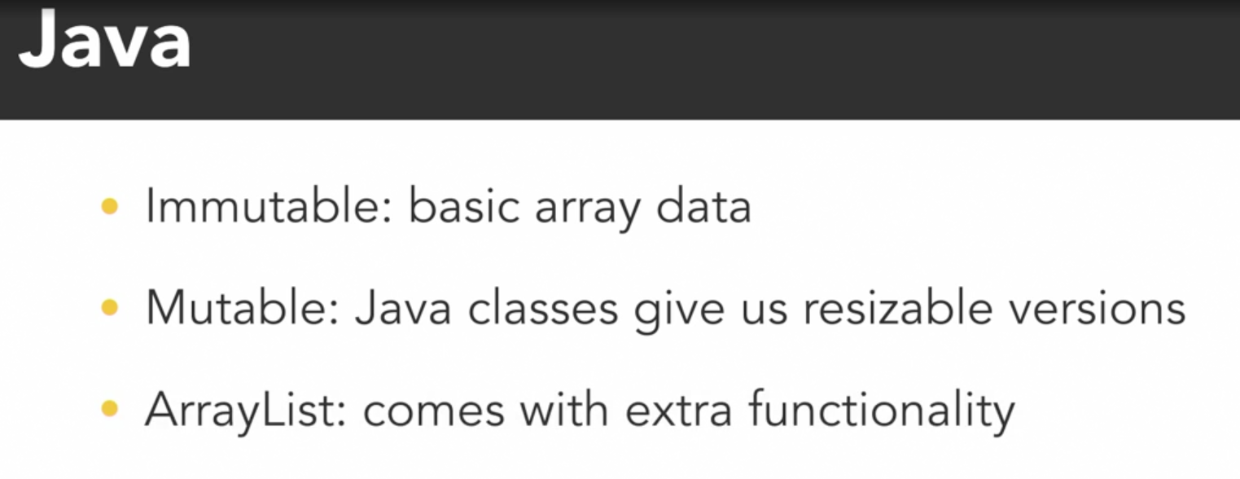

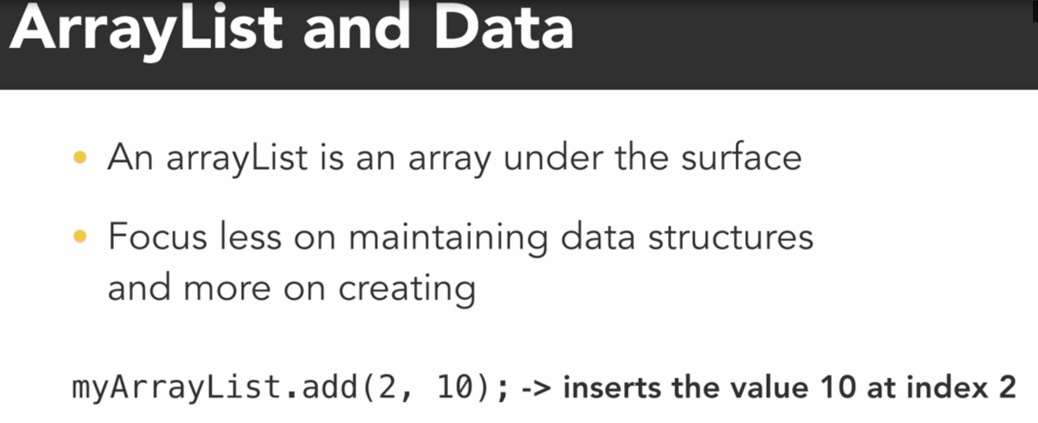

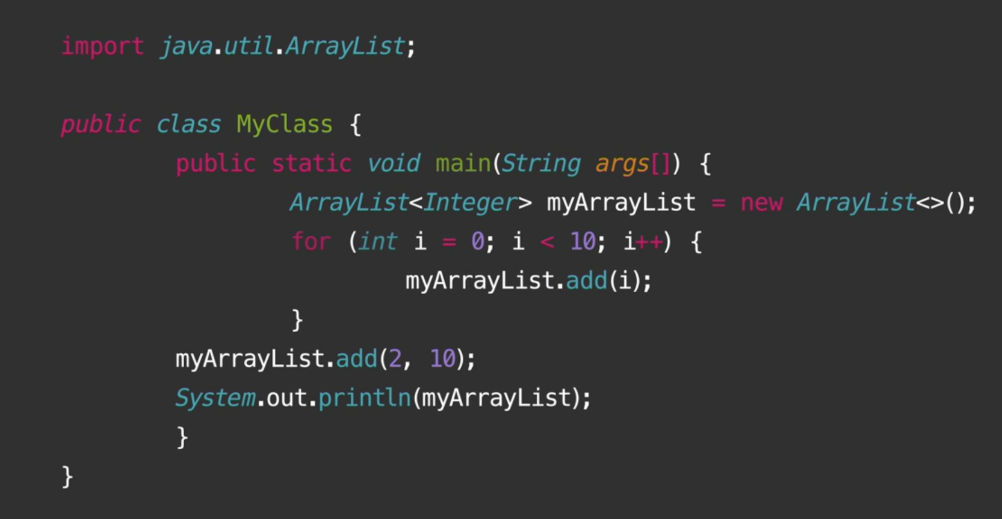

* Output of code : [0,1,10,2,3,4,5,6,7,8,9]

When index is not mentioned, basically…

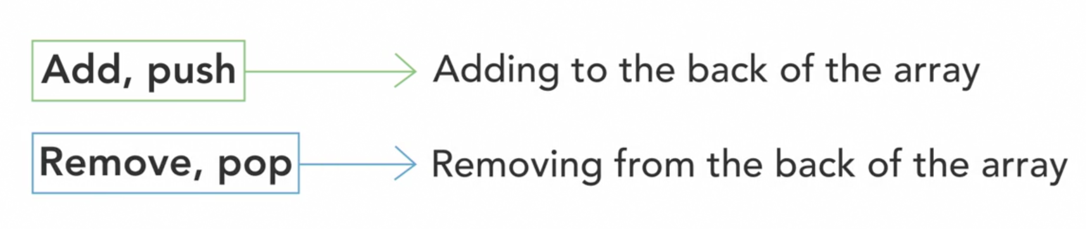

This insert functionality will be handled by programming lang by defining its own rules of executions…

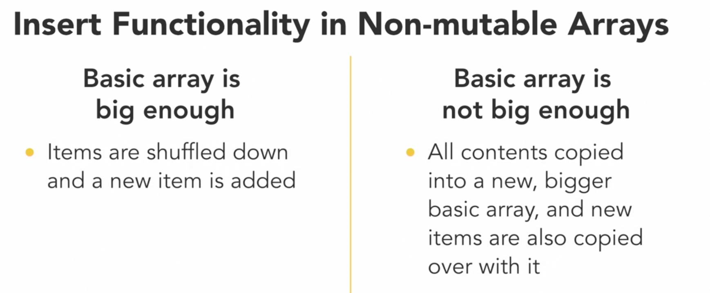

Search arrays :

* We able to access specific item in array with its index, so we directly use array in program flow
* Sometimes just to know present or not, sometimes need to know its index for further process of things..

Linear Search:

* Linearly/ sequential search => bruteforce check every item where its our searching item or not…

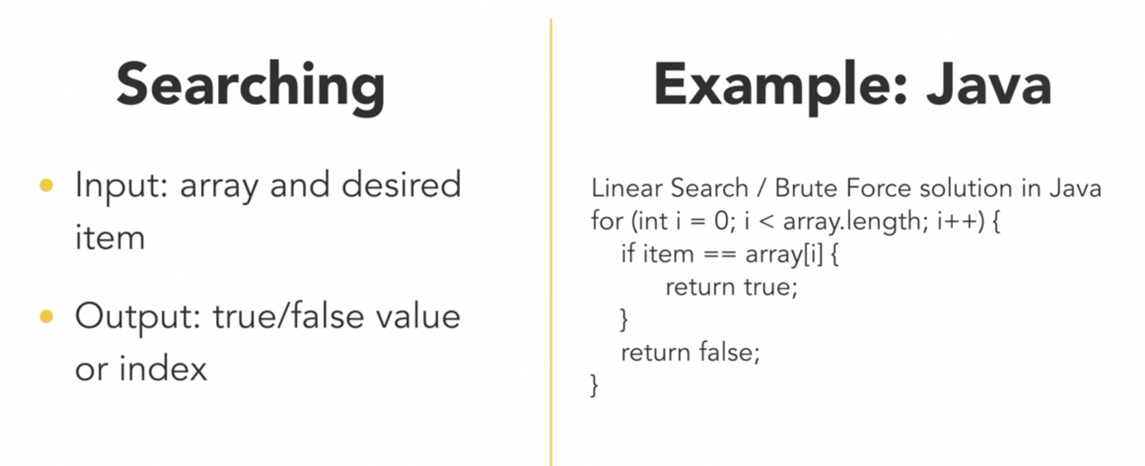

* Best case – 1st item, worst case – no searching item present in array
* more size,longer time it takes.. linear time algorithm..

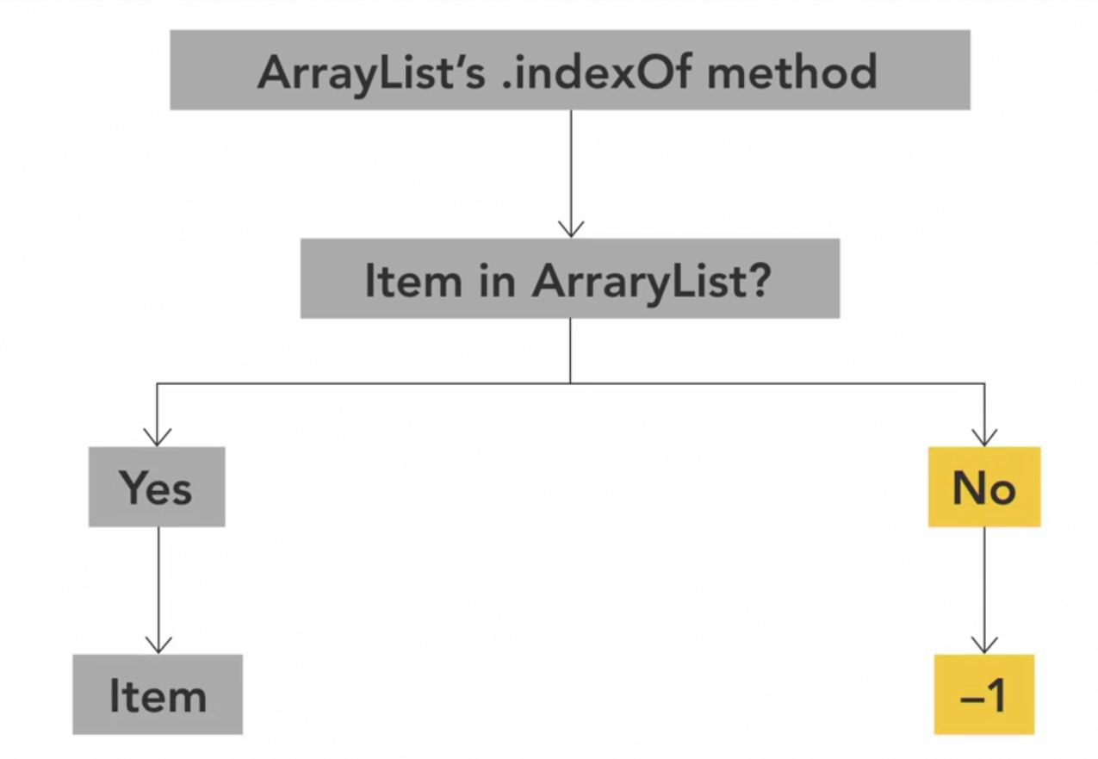

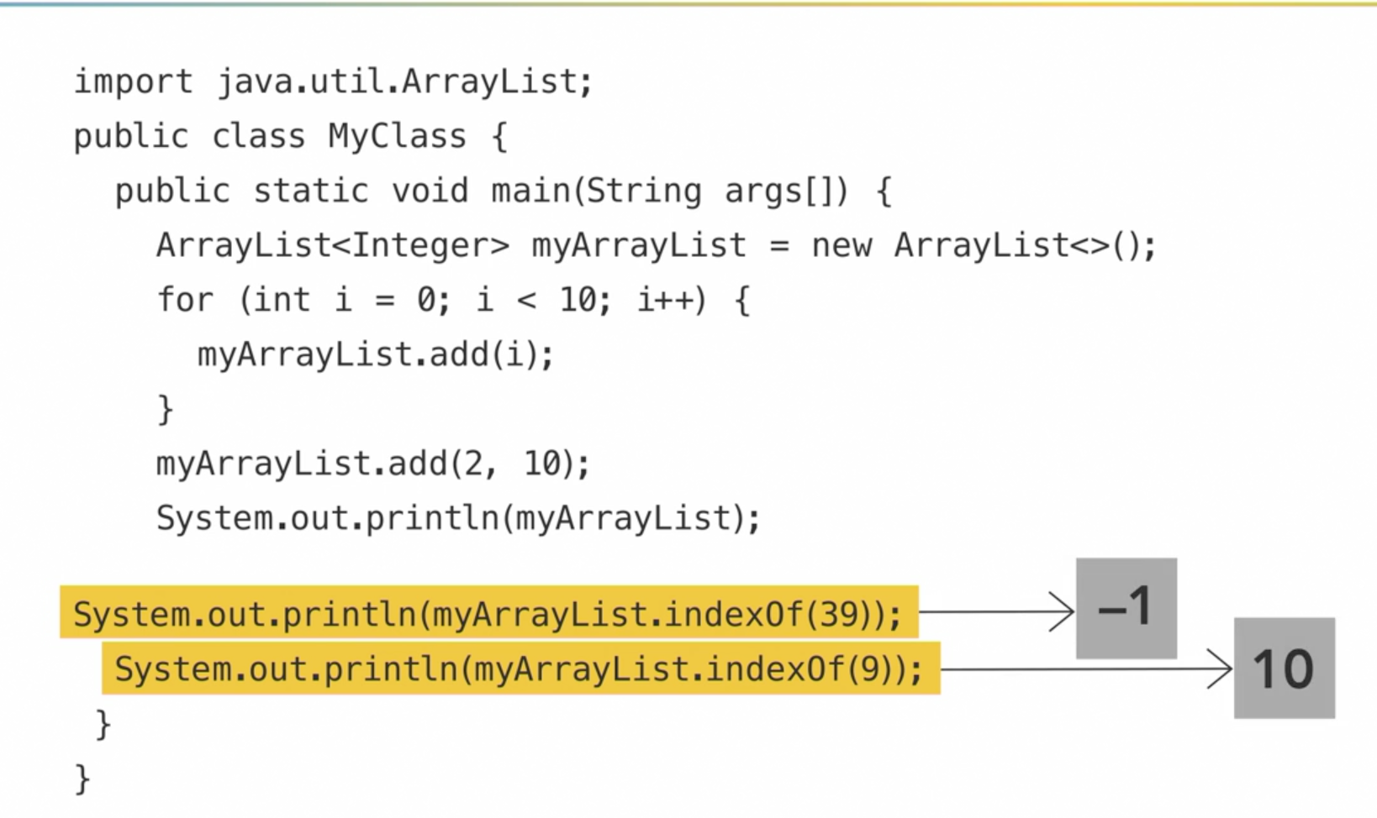

We can’t optimise linear algorithms since we don’t want to do any assumptions in data…  
its better to avoid linear algorithms in code since its time complexity is quiet high for large data…

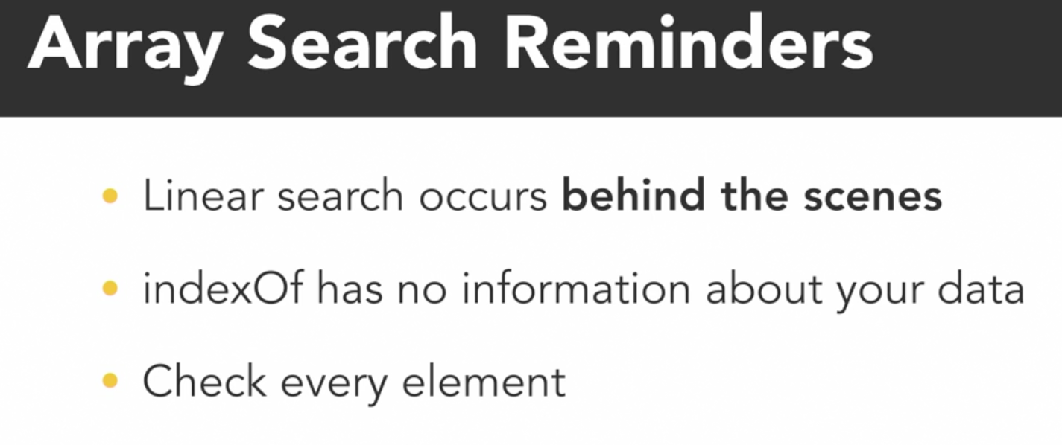

* But when the data is sorted, we have advantage of searching things faster.. where we can use Binary search

Sort:

* When planning to search for multiple items in array, redoing linear search for each item is worst approach, its better to sort once and search things with sorted array since its results in searching of each item faster enough…
* Sorting : - arranging elements based on something

Numbers => increasing or decreasing order

Strings/Chars => Alphabetical order

… or any custom order based on your priority…

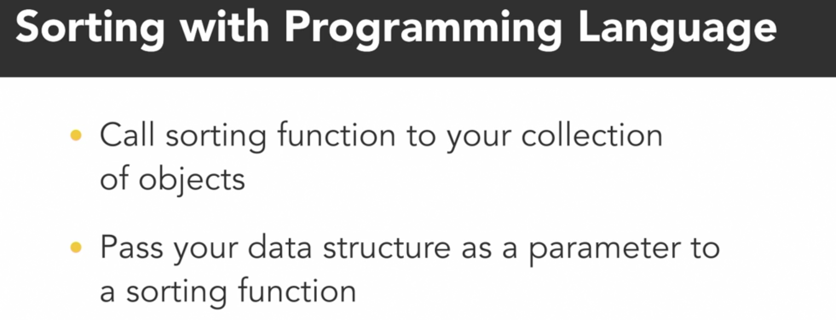

3 people example: no natural sorting order basically, we need to give sort based on what i.e comparator … ..

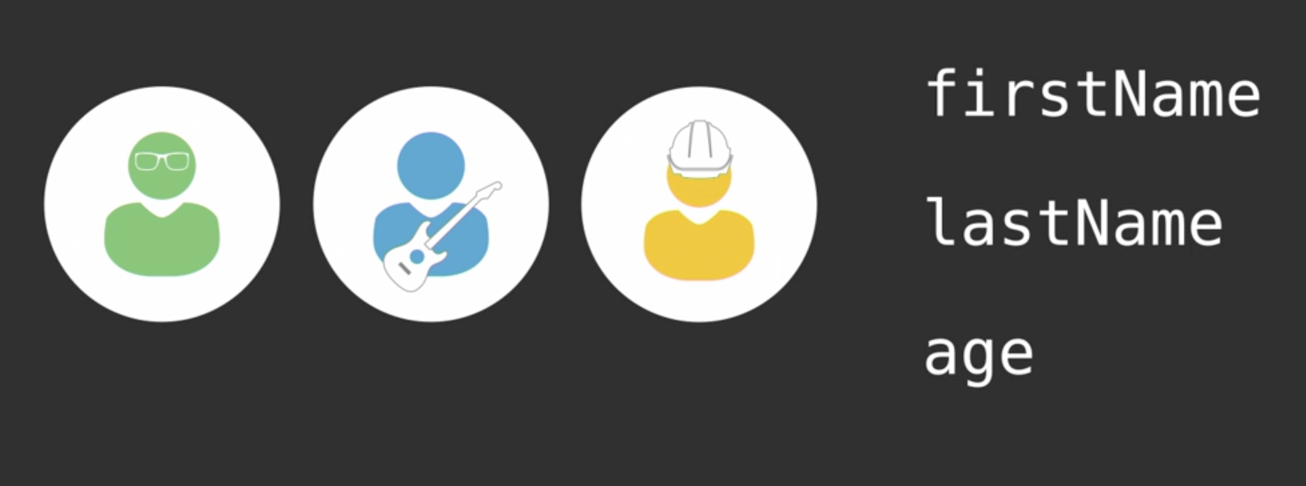

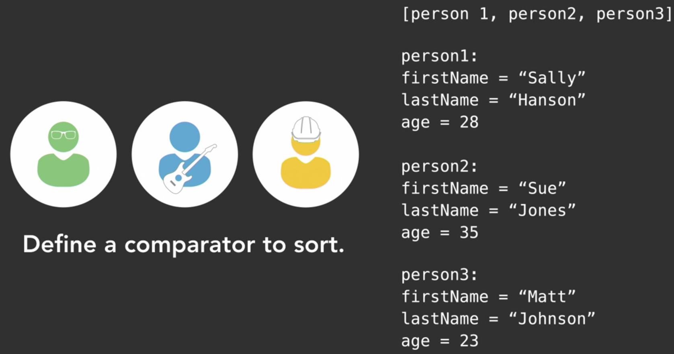

* Sorting basically complex (need lot of comparison checks) – different in time and space vary among which algorithms you use and algorithm selection will be done based on how much you know about your data..

Big O notations:

* Different algo and ds takes different complexities, to measure it in some common using, big O comes in…
* Big O – notation used to describe performance and complexity of an algorithm

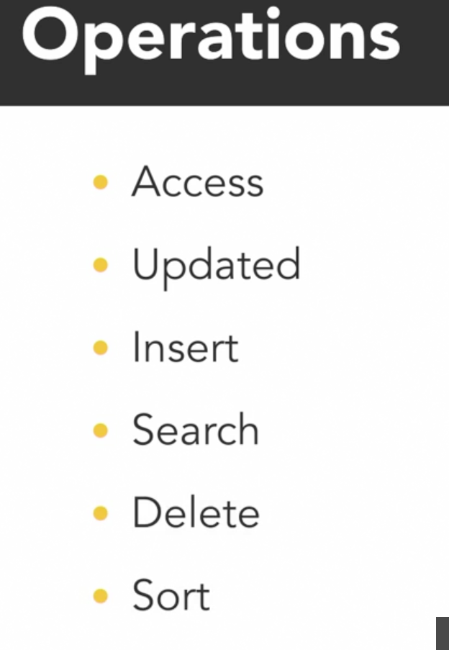

Access & Update:  
  
As long as you know the item index, access and update item in particular index takes constant time…   
  
if index not known, then to find we iterate through all elements, which is linear time..

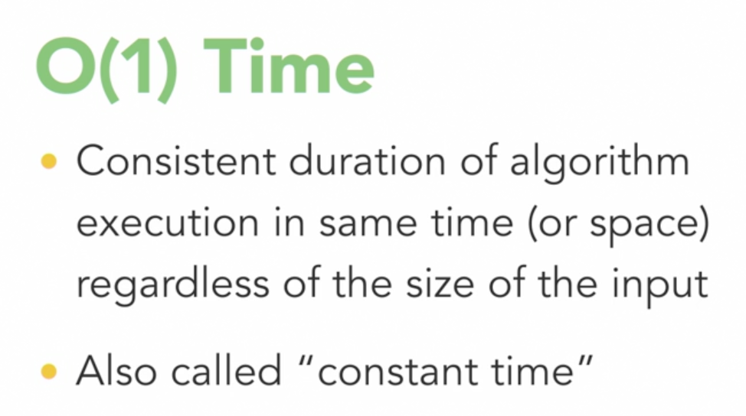

Insertion:

Array have empty space, then use empty space, else copy whole array to new array with new extra spaces.. where new items can fill in …

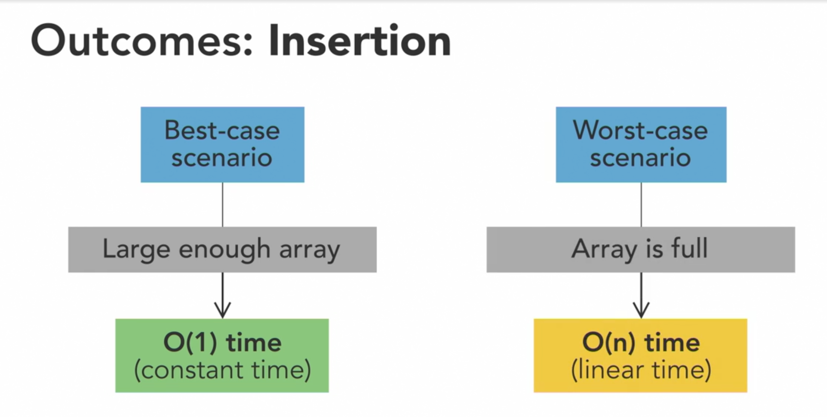

Search:

If not sorted / nothing known about data -> linear search ( item may found in 1st index , or not found upto last too )

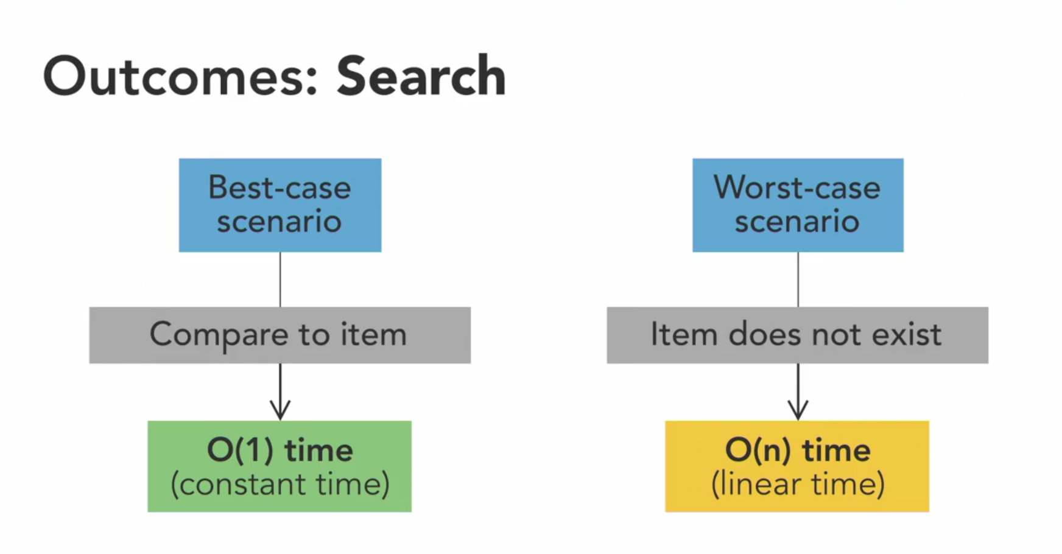

Deletion:

If index of item is known, deletion is constant, else find and delete is linear..

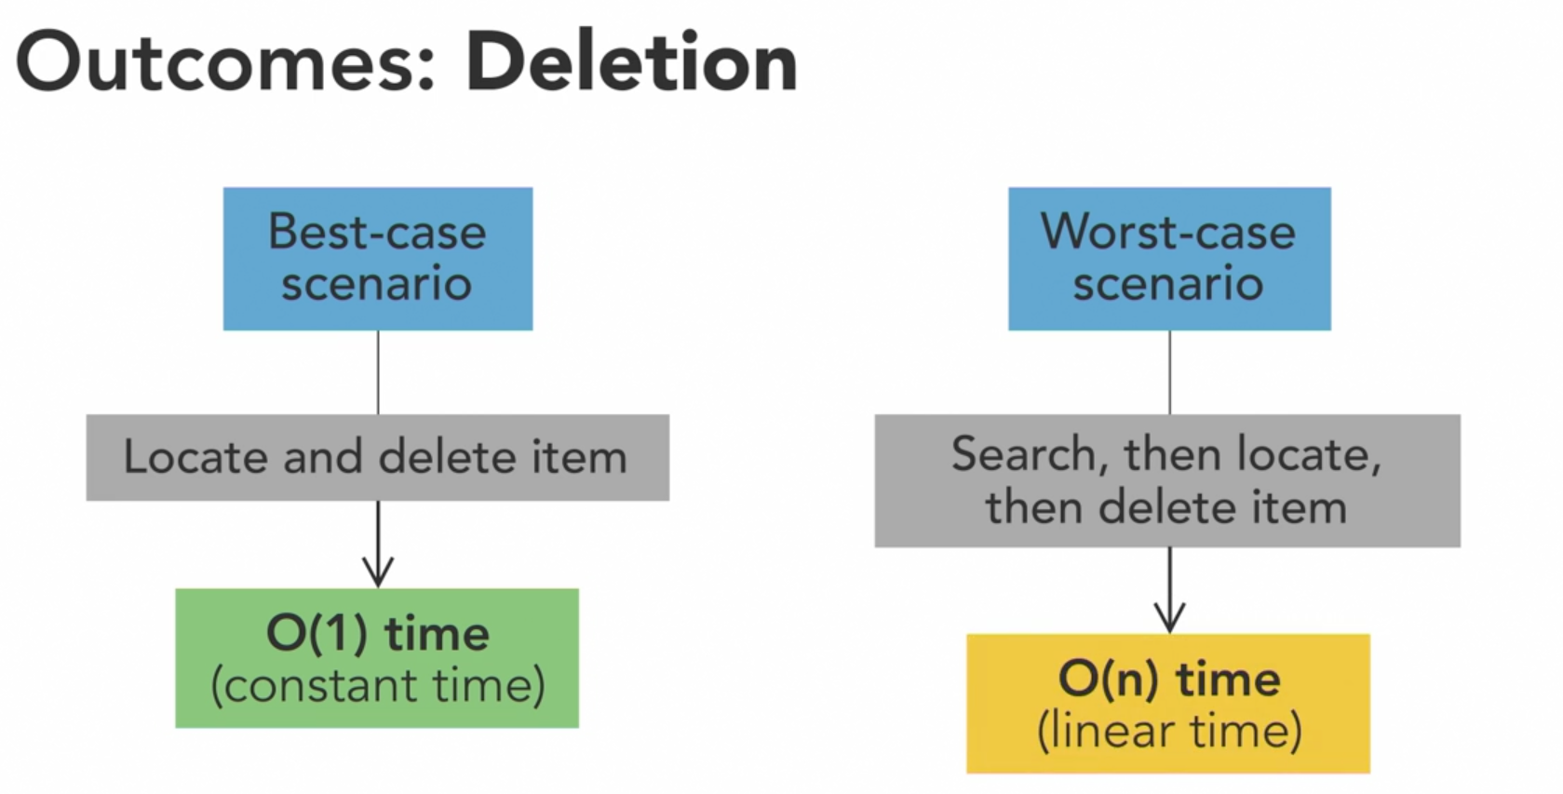

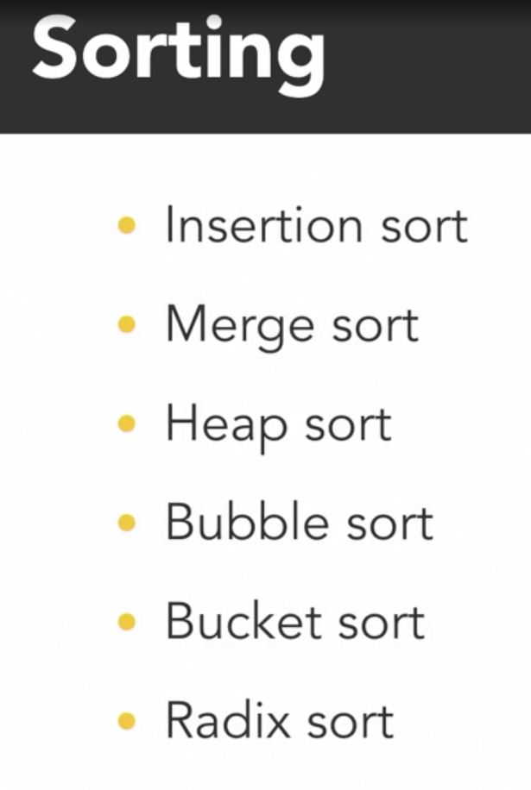

Some sort need prerequisites about data to work, some don’t  
  
basically more info about data, more logic put in to optimise…

Arrays – insertion, searching, sorting takes more time, but accessing will be so quick.. we can use array where access is done lot…

Linked List

* Similar DS like array but elements are not stored in continues memory location, Instead, we link the elements using pointers
* Like train with its train cars linked one by one…

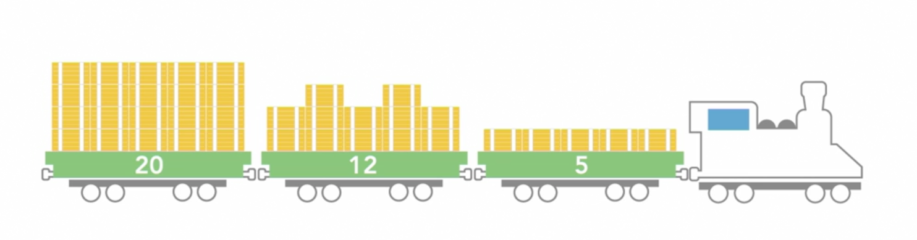

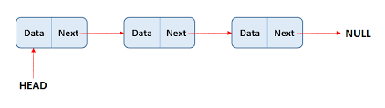

* Since it store only pointer (address), data can be anywhere in memory , not in continues memory location like arrays…
* The access of linked list elements can be done in order of one by one based on which order its linked..
* Each train car as Node – contains data and a pointer to next node..
* Head – first node of the linked list
* With head known, by accessing consecutive points , we can access every element of linked list
* Operations :  
  Access, Search – linearly iterate through one by one from head

Add – first => make current head as pointer of new node that is getting added … and make its address as head

* Last -> put current last’s item’s pointer to new node’s location and make new node’s pointer points to null

Delete –update deleting previous node’s pointer to current deleting element’s pointer value..

// Linked List in Java

class Node {

int data;

Node next;

Node(int d) { this.data = d;}

}

public class LinkedListFromScratch {

Node head;

public void add(int data) {

// LL is empty

if (this.head == null) {

this.head = new Node(data);

} else {

// LL is not empty

Node nodeToAdd = new Node(data);

nodeToAdd.next = this.head;

this.head = nodeToAdd;

}

}

public static void main(String[] args) {

LinkedListFromScratch myList = new LinkedListFromScratch();

myList.add(10);

myList.add(18);

System.out.println(myList.head.data); // 18

System.out.println(myList.head.next.data); // 10

}

}

// LinkedList Access in Java

import java.util.LinkedList;

public class MyClass {

public static void main(String args[]) {

// Note:Eventhough Java gives all methods like array,

// each action required some complexity of execution

LinkedList travelBucketList = new LinkedList();

// Add Items

travelBucketList.addFirst("Barcelona");

travelBucketList.addLast("Tokyo");

System.out.println(travelBucketList); //=> [Barcelona, Tokyo]

travelBucketList.add("Santorini"); // addLast

travelBucketList.add("Spain");

travelBucketList.add(2, "Galapagos Islands");

System.out.println(travelBucketList); //=> [Barcelona, Tokyo, Galapagos Islands, Santorini, Spain]

// Access

System.out.println(travelBucketList.get(2)); //=> Galapagos Islands

System.out.println(travelBucketList.getFirst());//=> Barcelona

System.out.println(travelBucketList.contains("Barcelona")); //=> true

// Remove Items

travelBucketList.removeFirst();

travelBucketList.removeLast();

System.out.println(travelBucketList);//=> [Tokyo, Galapagos Islands, Santorini]

travelBucketList.remove("Santorini");

travelBucketList.remove(0);

System.out.println(travelBucketList);//=> [Galapagos Islands]

}

}

Singly vs doubly :

Singly => have pointer to next item, we cannot traverse backwards

Doubly => have pointer to previous and next item, helps in trave both forward and backward..

Singly Linked List:

Contains nodes with data and a "next" pointer.

Allows traversal in only one direction (forward).

Cannot move backward in the list.

Doubly Linked List:

Includes nodes with data, a "next" pointer, and a "previous" pointer.

Enables traversal in both forward and backward directions.

Achieves this bidirectional navigation by adding a "previous" pointer to each node.

Often implemented in Java by modifying the node blueprint and introducing a "tail" node for the entire list.

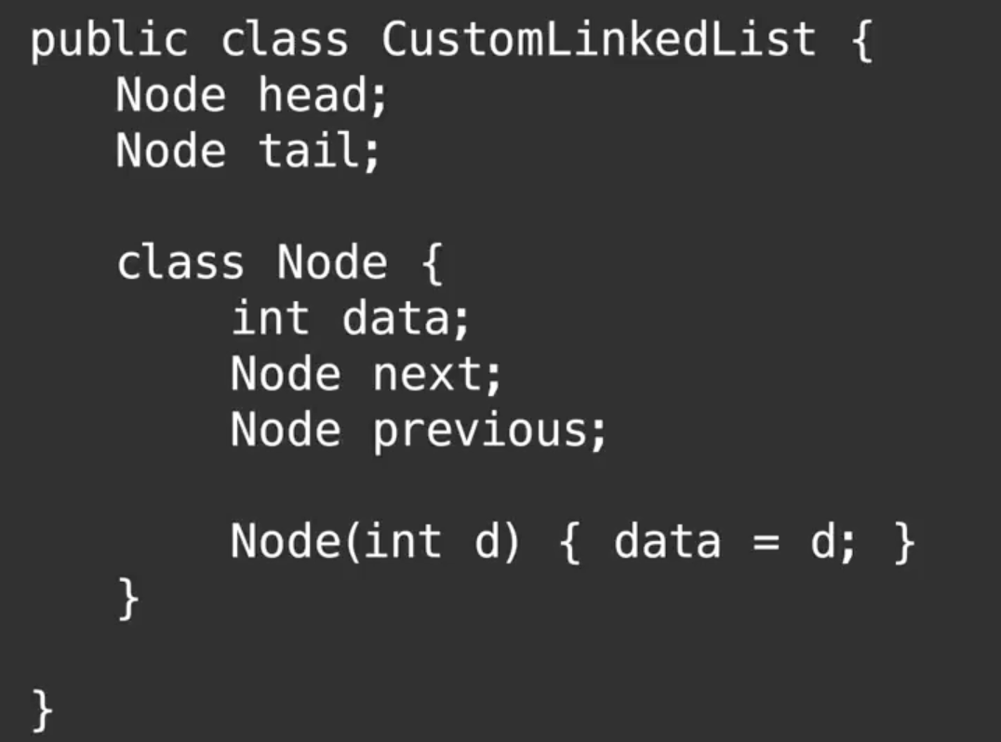

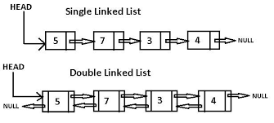

List in other lang:

The concept of lists can vary in meaning depending on the programming language you're using. Let's explore how lists are implemented in different languages and what they represent.

Java:

In Java, a list is not a data type itself. Instead, it's an interface provided in the java.util package. Think of an interface as an abstract definition. You can't create a plain list directly in Java, but you can create objects that support list behavior. For example:

List<String> arrayList = new ArrayList<>(); // ArrayList

List<Integer> linkedList = new LinkedList<>(); // LinkedList

Here, we've created two different types of lists using the List interface, one based on an ArrayList and the other on a LinkedList.

Python:

In Python, lists are actually resizable arrays, despite being called "lists." You can create and use them easily:

my_list = [1, 2, 3, 4] # Python list

While they are named "lists," they behave like arrays and are very versatile.

C#:

LinkedList<string> linkedList = new LinkedList<string>();

linkedList.AddLast("Node 1");

linkedList.AddLast("Node 2");

C# has a LinkedList class in the System.Collections namespace, which is a doubly linked list.

Swift, Ruby, and JavaScript:

In Swift, Ruby, and JavaScript, there are no built-in linked list implementations. However, you can find third-party libraries or create your custom implementations if needed. For example, in JavaScript:

// Custom linked list implementation in JavaScript

class Node {

constructor(data) {

this.data = data;

this.next = null;

}

}

class LinkedList {

constructor() {

this.head = null;

}

// Add methods to manipulate the linked list

}

const myList = new LinkedList();

In C++, the Standard Template Library (STL) provides a list container, which is a doubly linked list implementation:

#include <list>

std::list<int> myList; // Doubly linked list

In cases where your chosen language doesn't have a specific linked list implementation, it's not necessarily a problem. Most of the time, you'll find that array-like structures are more commonly used. Even for tasks that involve a lot of insertions and deletions, there are other data structures, like dynamic arrays or linked lists, that may be more suitable, and you can implement them as needed.

Search and sort and Access :

Pros and Cons of Linked Lists

When considering data structures like linked lists, it's essential to evaluate their performance using Big O Notation, which describes algorithm complexity. We'll assess common operations like Access, Update, Insertion, Search, and Deletion.

Accessing an Item:

Best case: Constant time if the item is at the front (head) of the linked list.

Worst case: Linear time because you may need to traverse the entire list to find the item.

Updating an Item:

Always takes linear time (O(N)) because you must locate the specific node to update.

Insertion (at Front):

If order doesn't matter, it takes constant time (O(1)) as you can prepend items efficiently.

Insertion (at End - Singly Linked List):

Takes linear time (O(N)) because you must traverse the list to reach the last element before inserting.

Insertion (at End - Doubly Linked List):

Can be more efficient, often O(1), as you have direct access to the last element.

Searching and Deletion:

In the worst case, both operations take linear time (O(N)) because you must locate the element in the list before acting upon it.

Sorting:

Sorting a linked list's time complexity depends on the sorting algorithm used. Merge sort is often preferred due to its efficiency with linked lists. Other algorithms like quick sort and heapsort are less ideal due to the slow, non-random access nature of linked lists.

Random Access:

Linked lists provide sequential (or direct) access, requiring traversal from the start to reach an item. This is in contrast to arrays, which offer immediate access by index.

Understanding these advantages and disadvantages is crucial for choosing the right data structure for your specific needs.

Stacks and Queues:

Stacks:

Stacks are a type of data container used for specific purposes. Ordered series of object like array but operations and things differ…

They follow a "last in, first out" (LIFO) policy.

Similar to a stack of pancakes, items are added (pushed) onto the top and removed (popped) from the top.

Adding or removing from the bottom of the stack requires lifting the entire stack.

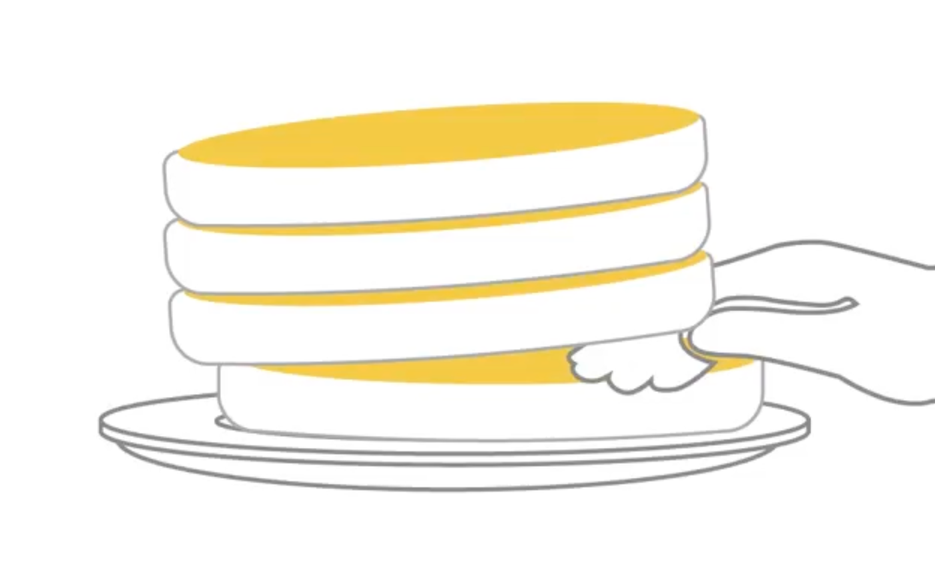

"Push" is the term used to add an item to the stack, and "pop" is used to remove an item.

Retrieving an item deep within the stack requires popping off items above it.

Stacks are useful for tracking the order of events or maintaining state.

Stack in swift:

In Swift, we don't have built-in stack functionality, so we'll create our own stack using a resizable array.

// Stack implementation in swift

class Stack {

// resizable array

var stackArray = [String]()

//push item at last

func push(item:String) {

self.stackArray.append(item)

}

//pop item from last

func pop()->String? {

if self.stackArray.last != nil {

let lastString = self.stackArray.last

self.stackArray.removeLast()

return lastString!

} else {

return nil

}

}

//peek last item

func peek() -> String? {

if self.stackArray.last != nil {

return self.stackArray.last

} else {

return nil

}

}

}

var deck:Stack = Stack()

deck.push(item: "Heart : Queen")

deck.push(item: "Spade : Jack")

deck.push(item: "Heart : 9")

deck.push(item: "Diamond : 4")

print(deck.peek()!) //=> Diamond : 4

print(deck.peek()!)//=> Diamond : 4

var firstItemPopped = deck.pop()

var secondItemPopped = deck.pop()

print(firstItemPopped!)//=> Diamond : 4

print(secondItemPopped!) //=> Heart : 9

Need to check {  
Dear Ms. Kathryn Hodge, Thank you very much for your great presentation. I'd like to make few remarks to swift stack implementation. You can just use stackArray.removeLast, the following method returns and removes the last element from your collection. It there is nothing to return it returns nil as required by the method definition. As well you can omit nil checks in your peek method because stackArray.last returns the last element of the collection or nil if there is nothing to return. Thank you  
}

Stacks follow the "last in, first out" (LIFO) principle, which means that the last item added is the first to be removed. In the context of a stack, we add items to the back of the array (top) and remove them from the back.

Stacks are not indexed data structures, so you can only access the top item directly. To access items in the middle of the stack, a different data structure should be used.

Think of a stack like a deck of cards: you add cards on top and remove cards from the top. To access the next item in the stack, you must remove the current top item.

Note: there is no indexing in any other than array DS.

It's important to note that when developers use a stack, they often don't need to know how it's implemented internally. In this case, we're using a resizable array and specific methods to operate on the stack. This abstraction allows developers to focus on building their applications without worrying about the underlying data structure details.

Extra:

Swift Optional things

In Swift, the ? and ! symbols are used in optionals to indicate whether a value can be nil or not. Optionals are a way to represent values that may or may not exist. Let's break down their usage:

? (Optional Chaining):

The ? symbol is used after a property, method, or subscript to indicate that it can be called on an optional value, and if the value is nil, the operation will gracefully fail without causing a runtime error.

let optionalValue: Int? = someFunctionThatMayReturnNil()

let result = optionalValue?.doSomething()

// If optionalValue is nil, result will be nil, otherwise, result will hold the result of doSomething()

! (Force Unwrapping):

The ! symbol is used to force unwrap an optional value, essentially telling the compiler that you are certain the value is not nil, and you want to access its underlying value.

Be careful when using ! because if the optional value is nil, it will result in a runtime error (a crash).

let optionalValue: Int? = someFunctionThatMayReturnNil()

let unwrappedValue = optionalValue!

// If optionalValue is nil, this will crash. Only use when you are absolutely sure the value is not nil.

It's important to use these symbols appropriately and with caution to handle optionals safely in Swift. Using ? for optional chaining is a safer way to work with optionals, as it avoids runtime crashes, while ! should be used sparingly and only when you are certain that an optional contains a value.

Call stack:

Stacks are a fundamental data structure used in programming.

In the context of programming, the runtime stack (or call stack) plays a crucial role.

The runtime stack keeps track of variables in scope and the current function or subroutine being executed.

It's essential for error tracing and understanding the program's flow when issues arise.

// stack in java && call stack view

import java.util.Stack;

public class MyClass {

public static void main(String args[]) {

Stack myStack = new Stack();

myStack.push("hi");

myStack.pop(); //=> hi

myStack.pop(); //=> no item to pop, runtime err

}

}

/* Program call stack

Exception in thread "main" java.util.EmptyStackException

at java.base/java.util.Stack.peek(Stack.java:101)

at java.base/java.util.Stack.pop(Stack.java:83)

at MyClass.main(MyClass.java:7)

*/

This error demonstrates how the runtime stack helps trace the error back to its origin.

Java, C#, .NET , you can get Stack class with methods like push, pop, peek to do things..

Python, Ruby, and JavaScript, you can use lists or arrays as stack data structures.

Queues:

Definition: Queues are ordered data structures used in programming.

FIFO Principle: Queues follow a "First In, First Out" (FIFO) policy, similar to waiting in line.

Front and Back: Like a real-world queue, a code-based queue has a front and a back.

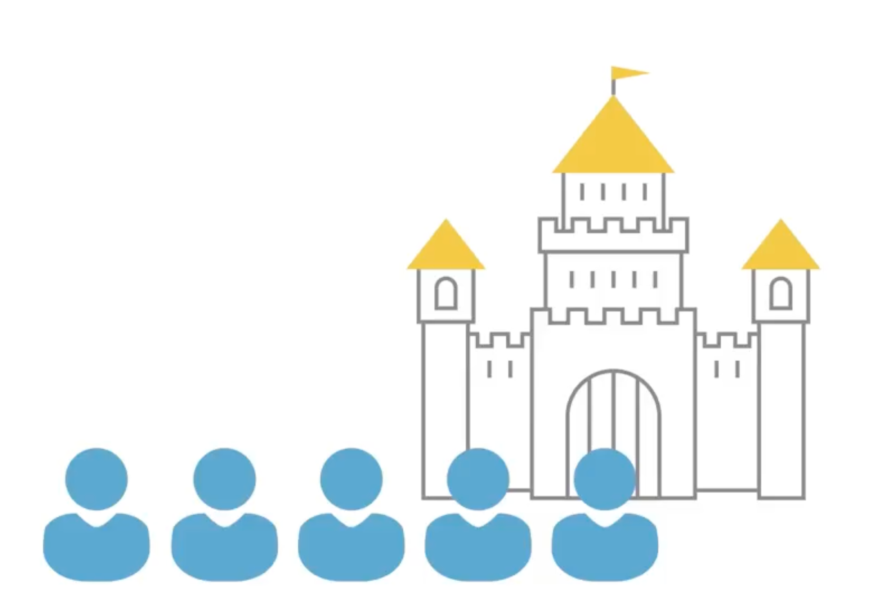

Add back , remove front, peek front..

Operations:

Enqueue: Adding elements to the end of the queue.

Dequeue: Removing elements from the front of the queue.

Peek: Viewing the first item without removing it.

Implementation: Queues are implemented using a list, with careful control over operations to maintain the structure.

Usage: Queues are handy for scenarios where order and sequence matter, such as processing tasks in the order they were received.

Swift implementation:

Peeking and Removing item from front is the only change to make stack into queue…

You can add extra things like deQueueAll or find size of queue..

// Implementation of queue in swift

class Queue {

var queueArray = [String]()

func enqueue(item: String) {

self.queueArray.append(item)

}

func dequeue() -> String? {

if self.queueArray.first != nil {

let firstString = self.queueArray.first

self.queueArray.removeFirst()

return firstString!

} else {

return nil

}

}

func peek() -> String? {

if self.queueArray.first != nil {

return self.queueArray.first

} else {

return nil

}

}

}

var myQueue = Queue()

myQueue.enqueue(item: "Peggy")

myQueue.enqueue(item: "Larry")

myQueue.enqueue(item: "Serena")

print(myQueue.peek()!) //=> Peggy

print(myQueue.peek()!) //=> Peggy

// storing in return since it give error becoz func returning value

var firstToLeave = myQueue.dequeue()

print(myQueue.peek()!) //=> Larry

Queues in various programming languages are used for managing ordered tasks or data with different implementations and terminology. Here's a summary of how queues work in different languages:

Operating Systems and General Usage:

Queues are used in operating systems to control access to shared resources like printers, files, and communication lines.

They are common in multi-threading and concurrency scenarios for task scheduling.

Implementation Options:

Queues can be implemented using linked lists or dynamic arrays, depending on the language and requirements.

C#:

In C#, there's a built-in Queue class.

You can use Enqueue and Dequeue methods to add and remove elements from the queue.

Python:

Python has a Queue class with put and get methods for adding and removing items.

It's optimized for working with threading and thread synchronization.

Ruby:

Ruby doesn't have a specific queue class, but you can use the standard array.

Use the push method to add items to the end and shift to remove and return the first element, which effectively acts as a queue.

Rebu uses queues to synchronizing communications across threads.

JavaScript:

In JavaScript, dynamic arrays can be used as queues.

Utilize the push method to add items to the end and shift to remove and return the first element.

C++:

C++ provides a queue container in the standard template library.

You can use push_back to add elements to the back of the queue and pop_front to remove and retrieve the front element.

General Guidance:

Regardless of the language you're using, you can typically find libraries or built-in classes that offer queue functionality.

Alternatively, you can implement queues yourself based on your specific needs.

In different languages, the terminology and built-in classes for queues may vary, but the core concept of managing ordered tasks remains consistent.

Specicalized Queues:

* Queues with extra constraints

Specialized queues include priority queues and DEQUEKs (pronounced "deck"), which offer unique functionalities:

Priority Queue:

A priority queue assigns a priority level to each element.

Elements can be added at any time, but the next item to dequeue is the one with the highest priority.

This priority could be as simple as a number so that new items could be added to the queue ahead of those already there which have lower priority then current. However, if you add multiple items that have the same priority, they will queue as normal first-in, first-out order.  
  
Priority is determined by a comparator or compare function.

Java and C++ have support for priority queues, requiring custom comparators.

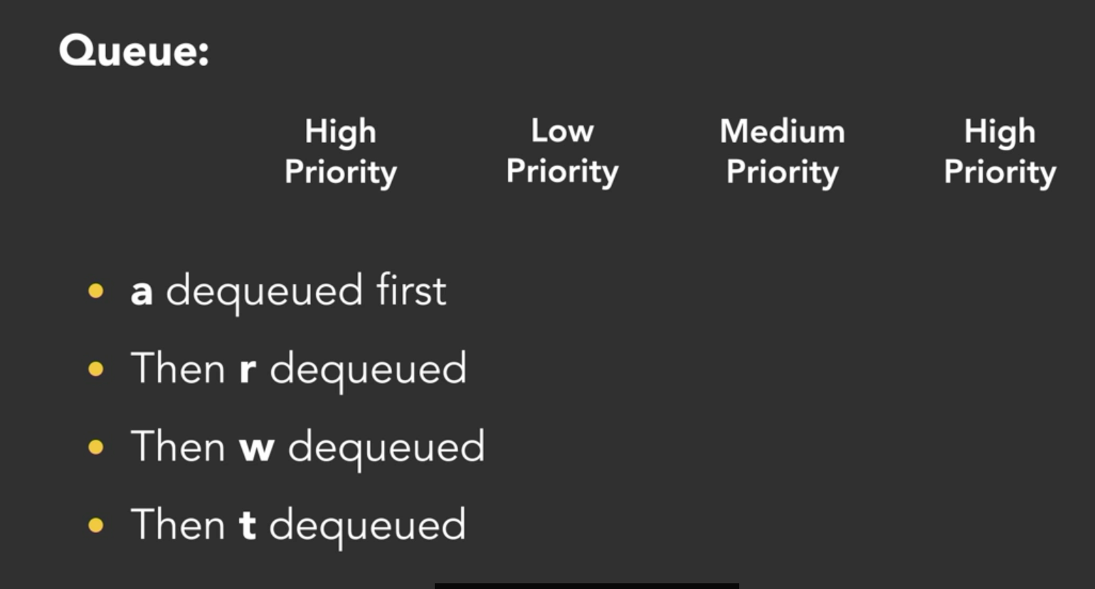

DEQUEK (Double-Ended Queue):

A DEQUEK combines features of both a stack and a queue.

Items can be added and removed from either end but not from the middle.

Java:

Java provides an interface called Deque that defines the behavior of a DEQUEK.

Classes like LinkedList in Java implement this interface, allowing you to use them as a DEQUEK.

You can add and remove elements from both ends of the DEQUEK using methods like addFirst, addLast, removeFirst, and removeLast.

C++:

C++ includes a container type called std::deque (short for "double-ended queue") that serves as a DEQUEK.

You can use methods like push_back, push_front, pop_back, and pop_front to add and remove elements from the back or front of the DEQUEK.

Python:

Python has a built-in deque class available in the collections module, specifically designed to work as a DEQUEK.

It's optimized for efficient adding and removing of elements from both ends.

You can use methods like append, appendleft, pop, and popleft to manipulate the DEQUEK.

Ruby:

Ruby does not have a built-in DEQUEK class.

You can emulate DEQUEK behavior using an array/LinkedList.

To add an element to the front, you can use the unshift method, and to remove from the front, you can use the shift method.

To add to the back, you can use the push method, and to remove from the back, you can use the pop method.

.NET (C#):

.NET does not have a built-in DEQUEK class.

You can mimic DEQUEK behavior using a LinkedList or a custom array implementation.

To add to the front, you can use the AddFirst method, and to remove from the front, you can use the RemoveFirst method.

To add to the back, you can use the AddLast method, and to remove from the back, you can use the RemoveLast method.

Most languages support the idea of adding and removing from the back or front of the data structure. However, it's important to be aware of how large your structure gets, as shuffling the elements around is not very efficient

Pros and cons of stack and Queue:

Stacks:

Pros:

Ideal for reversing data or strings by pushing and popping items one at a time.

Efficient for tracking state changes in programs.

Quick operations (push, peek, pop) when adding and removing from the back.

Typically implemented with linked lists or dynamic arrays.

Cons:

Inefficient for accessing specific items in the middle, as it requires popping elements off the stack.

Unsuitable for searching or sorting items systematically.

Only Best suited for "last in, first out" (LIFO) scenarios.

Queues:

Pros:

Efficient for "first in, first out" (FIFO) operations, such as enqueuing at the back and dequeuing from the front.

Quick operations due to doubly-linked list implementations.

Suitable for managing ordered tasks or data with specific sequence requirements.  
Priority queues for managing priority order of things to get executed…

Cons:

Not efficient for frequent access to items in the middle.

Inappropriate for searching or sorting items systematically.

Most beneficial for scenarios where items should be processed in the order they were received.

In summary, stacks and queues are valuable data structures but excel in specific scenarios. Stacks are great for LIFO situations and tracking state changes, while queues are ideal for FIFO operations and maintaining ordered sequences. The choice between them depends on the specific requirements of your program or problem.

Hash based Data Structures:

Hash => differs from other DS totally…

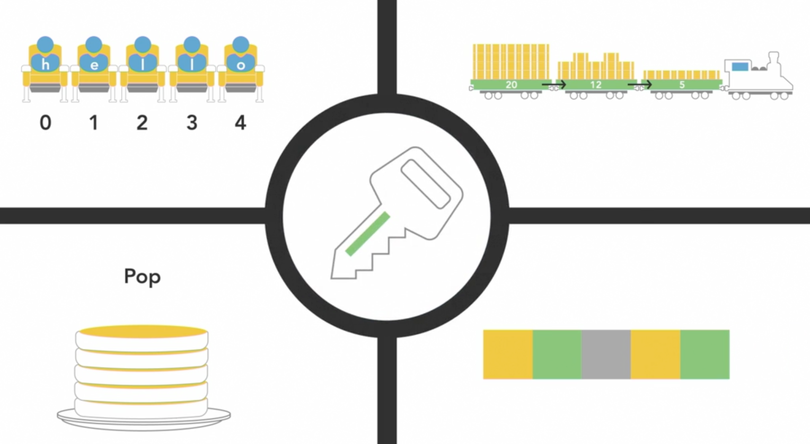

Associative arrays, also known as dictionaries or maps, are a data structure that stores a collection of key-value pairs.

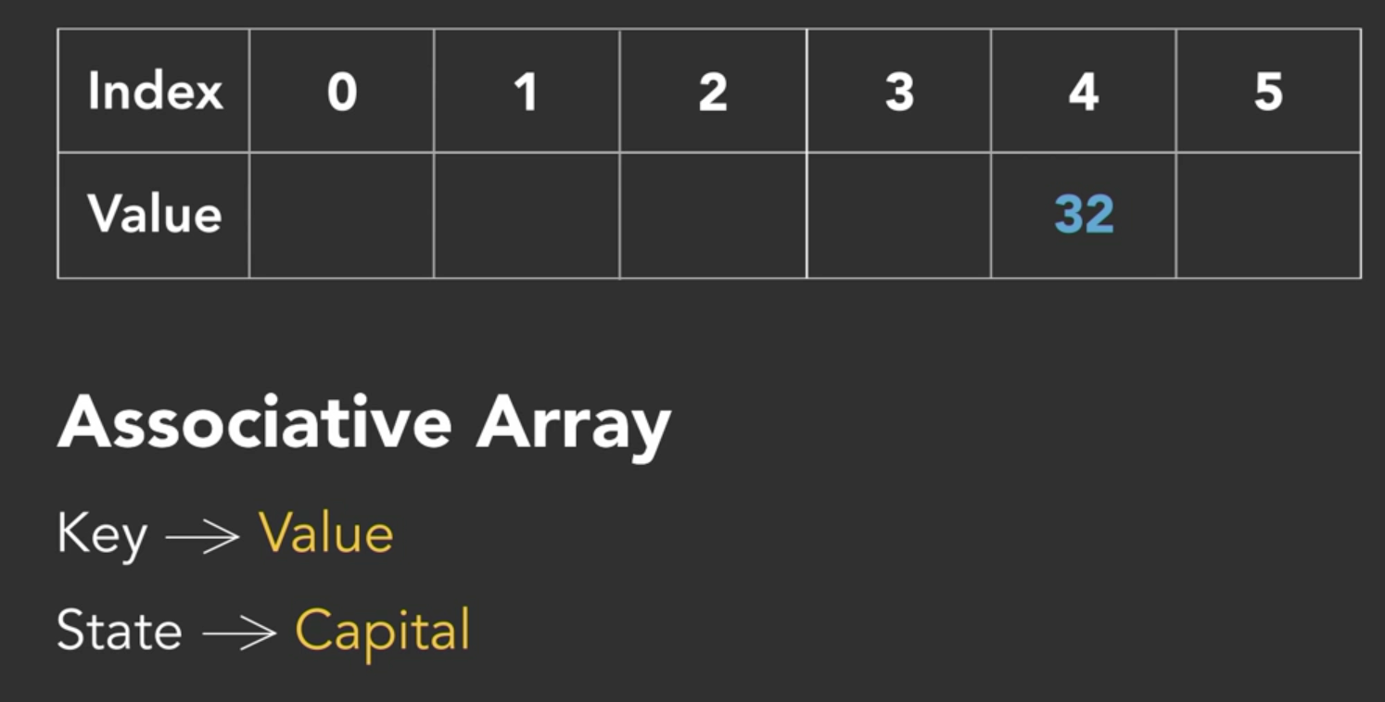

Key-Value Pairs: Associative arrays consist of pairs of elements, where each pair has a unique key associated with a corresponding value. The key is used to access the value.

Meaningful Data Access: Unlike traditional arrays where elements are accessed by numeric indices, associative arrays allow you to access data using meaningful keys. This makes it easier to retrieve and manipulate specific data elements.

Example Use Case: One common example is storing state capitals. Here, the state names would serve as keys, and their respective capital cities would be the corresponding values.

Flexibility: You can choose whether to use the key as the state name to find the capital or use the capital city to find the state. It depends on which piece of information you're more likely to have at hand when accessing the data.

Application in Flash Card Games: Associative arrays are valuable in educational applications like flash card games. The question can be the key, and the answer can be the value. This structure allows easy retrieval of answers based on questions.

Uniqueness: Every key in an associative array must be unique, just as indices are unique in regular arrays. Duplicate keys are not allowed because they serve as the unique identifier for the associated value.

No Order Requirement: Unlike traditional arrays where order matters, associative arrays do not rely on the order of key-value pairs. You access the data by specifying the key, and the data structure takes care of retrieval.

Abstract Data Type: Associative arrays are considered an abstract data type, similar to other data structures like arrays, linked lists, stacks, and queues. They provide a specific way to organize and access data based on meaningful keys.

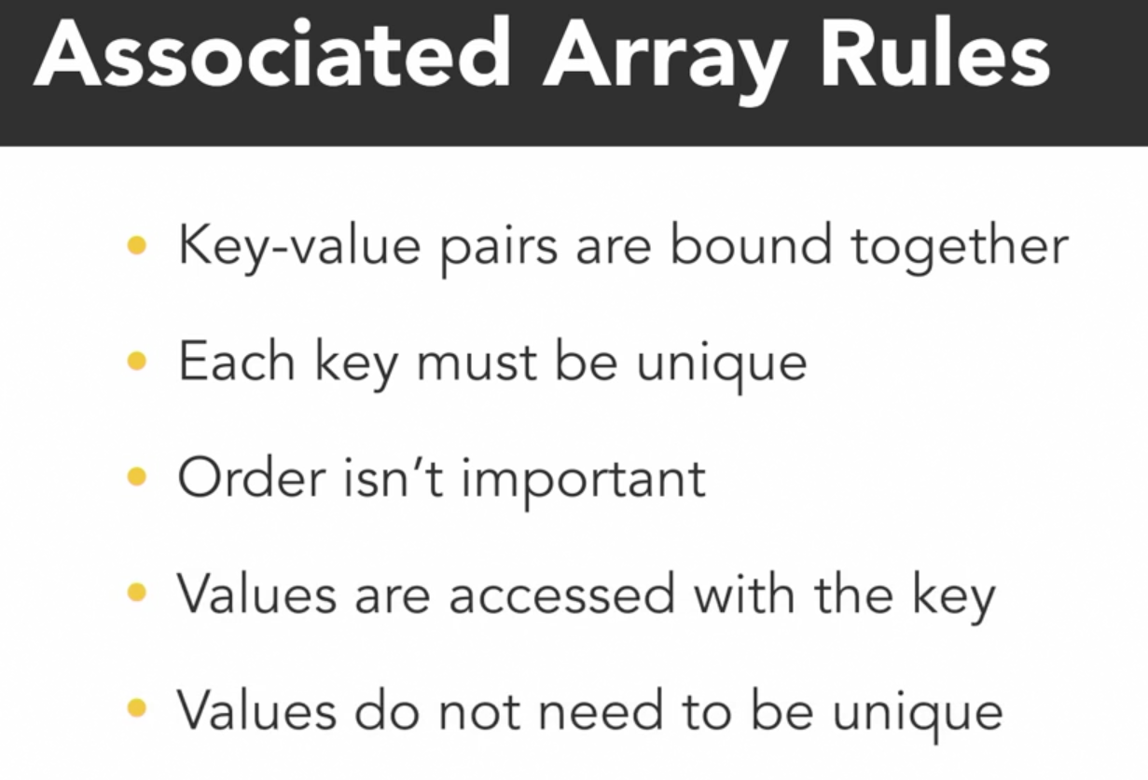

Understanding hash functions:

Most associative arrays, whether they are dictionaries, maps, or hashes, are implemented using a hash table.

Hashing Basics:

Hashing is a process of transforming raw data into a smaller, fixed-size piece of data, called a hash.

It's similar to cooking hash browns, where various ingredients are combined to create the final dish (the hash).

In computing, raw data is processed through a hash function to generate a hash value.

Hash Functions:

A hash function is a mathematical algorithm that converts input data into a hash value.

Importantly, hash functions are one-way and non-reversible, meaning you can't retrieve the original data from the hash value.

This property enhances security by preventing the retrieval of sensitive information from the hash.

Mostly input will be character, number, object and output will be integer in hash func…

Use Cases:

Hashing is commonly used for securing sensitive information, such as passwords.

For instance, instead of storing plain-text passwords in a database, websites store their hashes. When users log in, the system hashes their entered password and compares it to the stored hash.

Hash Function Example:

A simple hash function may convert characters in a string to their ASCII values and sum them up to produce an integer hash value.

For instance, the string "twentytwoever" might be converted to ASCII values (e.g., 'T' to 116, 'W' to 119) and summed to yield a hash value like 1463.

Collision:

Hash functions aim to produce unique hash values for distinct inputs.

When two different inputs yield the same hash value, it's called a collision. Hash functions strive to minimize collisions for security reasons.

Not Encryption:

Hashing differs from encryption. Encryption is reversible; there's a way to decrypt encrypted data. Hashing is not reversible; you can't "unhash" a hash value.

Practical Usage:

In programming, hash values are used to efficiently access or store data in specific locations, such as in hash tables or data structures like associative arrays.

Understanding hash functions is essential for various security and data retrieval applications, especially in safeguarding sensitive information like passwords.

Bank security of Database:

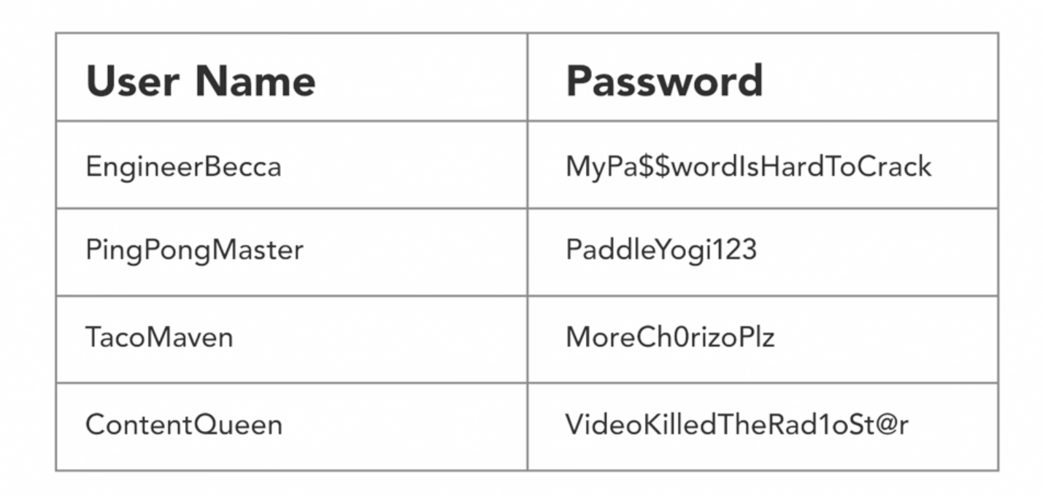

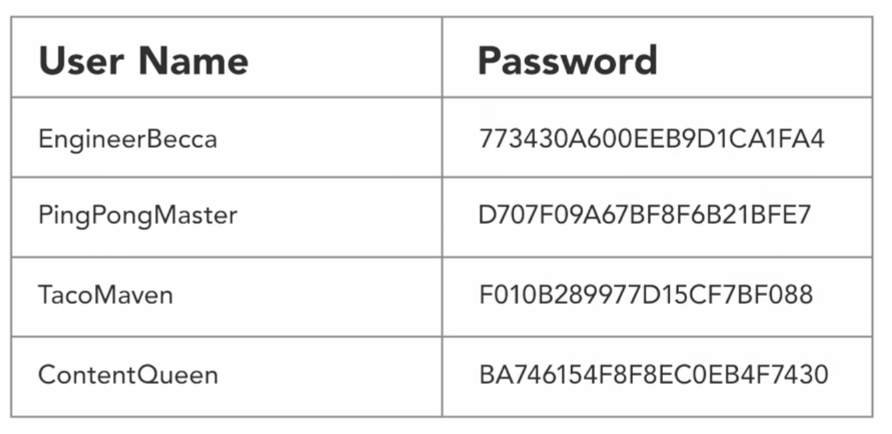

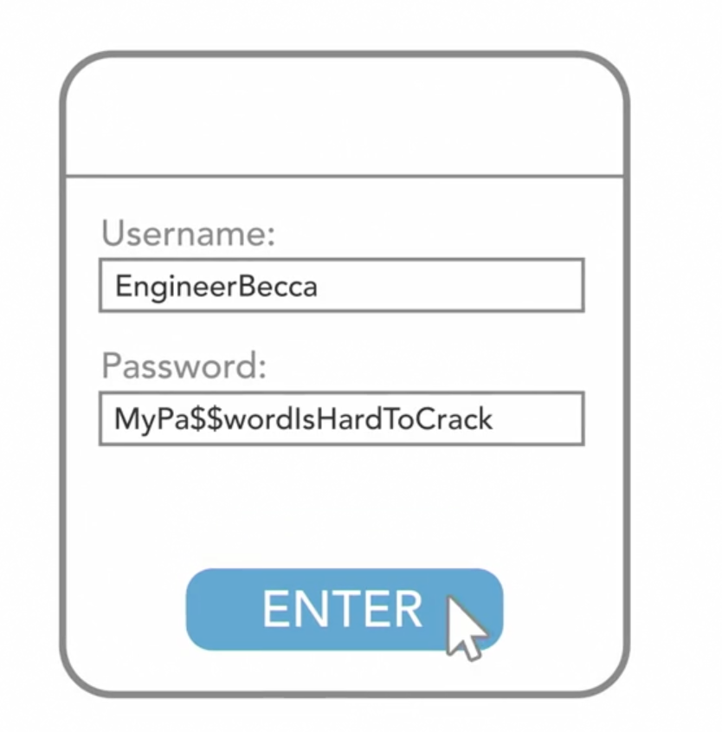

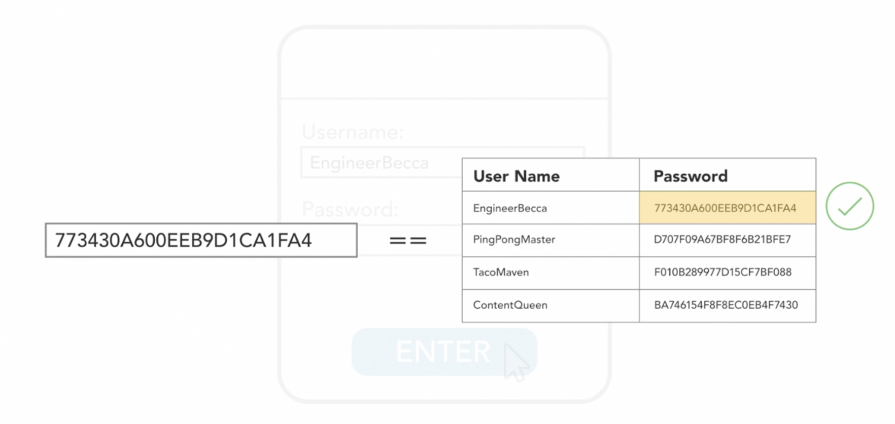

Since passwords is in hash, company people holding your account also don’t know the real password, so only while updating password, company don’t able to say your old password.. instead send a link to put new password…

Understanding Hash Table:

Hash Table Basics:

A hash table is a common way to implement an associative array, offering more functionality than a basic array.

In a hash table, entries for key-value pairs are referred to as "buckets," and you always add a pair, not just a key or value.

Adding Entries:

To add a new key-value pair to a hash table, a hash function processes the key to generate an integer hash value.

This hash value is usually too large to be directly used as an array index, so further calculations are needed to determine the index.

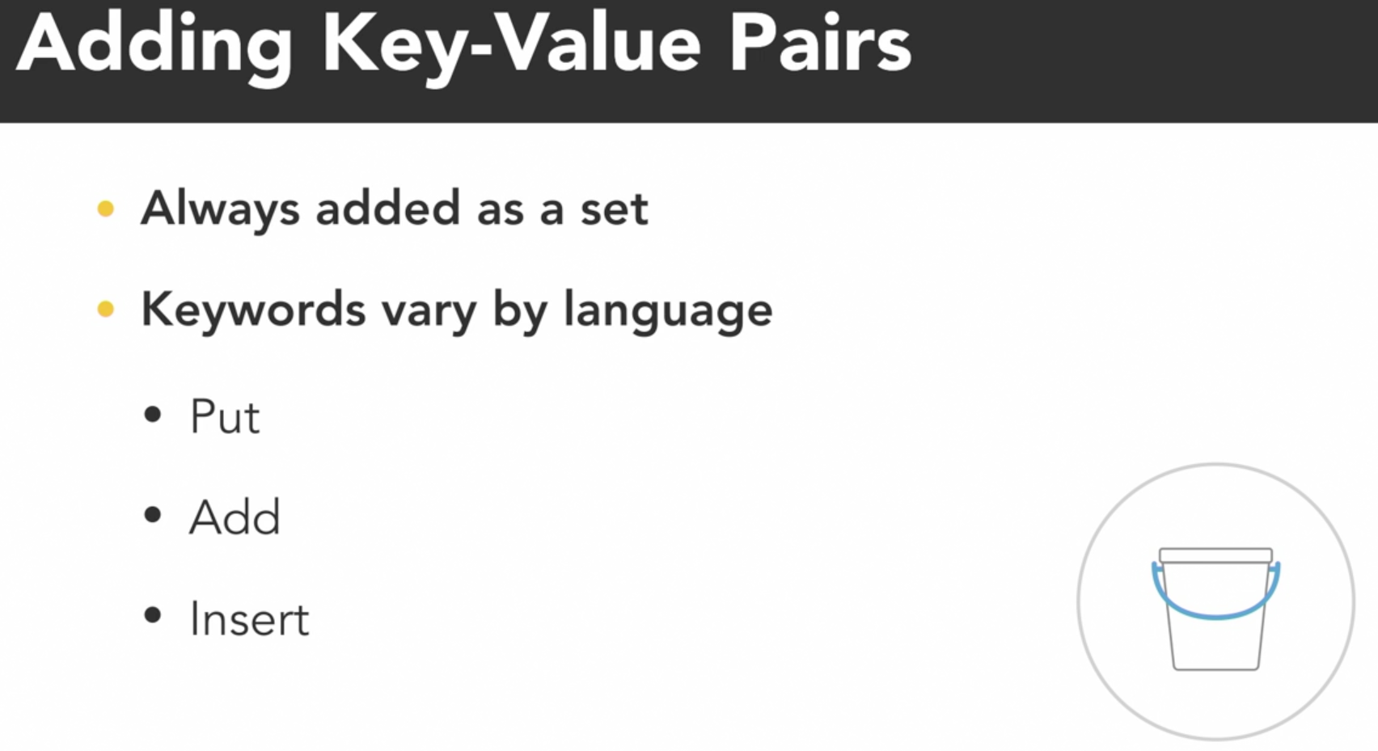

Index Calculation:

The goal is to make the integer hash value smaller while still being related to the hash table's size.

A common method is to use a modular operation, where the hash value is divided by the table size, and the remainder becomes the index.

Benefits of Hashing:

This indexing approach allows for quick retrieval of values based on their keys, as it directly maps keys to specific locations without linear searching.

Collisions:

Sometimes, different keys can produce the same hash value, leading to collisions.

To handle collisions, one approach is "separate chaining," where a linked list stores multiple values with the same hash in the same bucket.

Performance Considerations:

While individual bucket access remains fast, traversing linked lists in the event of a collision can impact performance.

Ideally, collisions should be infrequent to maintain the efficiency of hash table lookups.

When collisions increases, we loose our performance advantages on hast tables.

Collision Management Techniques:

Various techniques exist to manage collisions within hash tables, and the choice often depends on the programming language and libraries available.

In summary, a hash table is a data structure used for implementing associative arrays. It uses hash functions to map keys to specific locations (buckets) efficiently, with strategies like separate chaining employed to handle collisions. Efficient collision management is crucial for maintaining fast data retrieval in hash tables.

Implementation of hash:

# dictionary in python

# Key: State

# Value: Capital

statesToCapitals = {}

statesToCapitals["Texas"] = "Austin"

statesToCapitals["New York"] = "Albany"

print(statesToCapitals["New York"]) #=> Albany

print(statesToCapitals) #=> {'Texas': 'Austin', 'New York': 'Albany'}

Hash lang. support:

Certainly, here's a straightforward summary of language support for hashing:

Built-In Hash Functions:

Most programming languages provide built-in support for hashing.

Java has a hashCode method for every class.

Swift objects have a hashValue property.

.NET offers a GetHashCode function.

Python and Ruby have their own hash functions.

JavaScript typically requires custom hash function implementation or using appropriate modules from Node.js and npm.

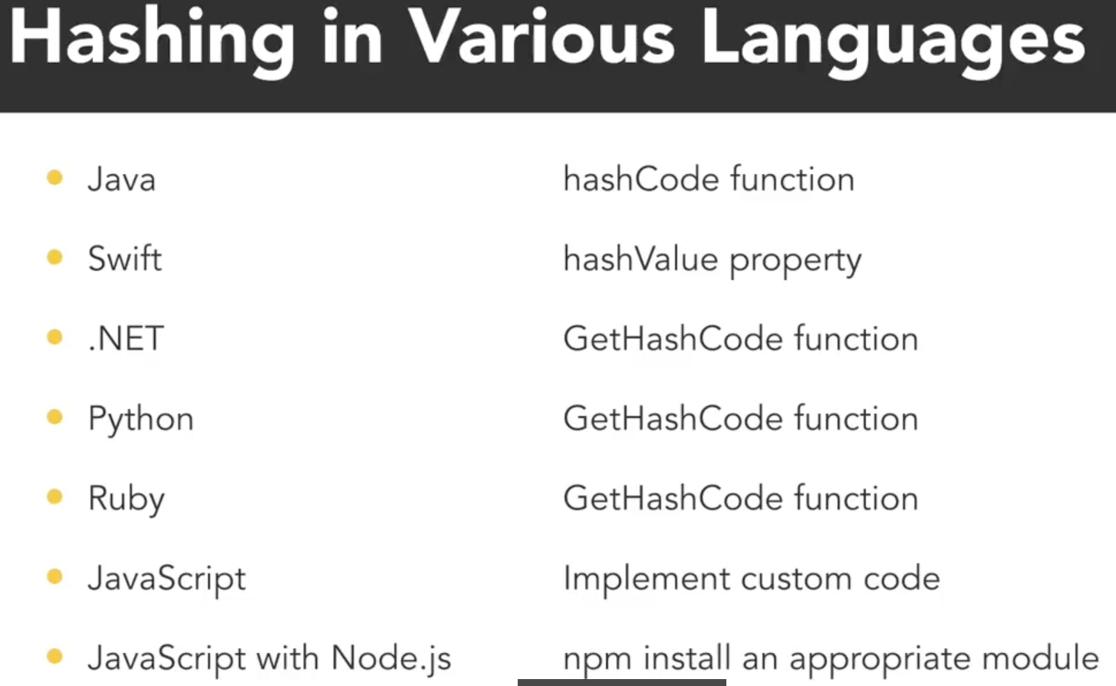

Default Hash Values:

These built-in hash functions return integer values.

The hash value is often calculated based on an object's ID or underlying memory address.

If two references point to the same object, they will produce the same hash value.

Equality Consideration:

By default, objects are considered equal if they are the exact same object in the same memory location.

Custom objects may require defining custom hash functions if equality should be based on the internal state of objects.

This ensures that different objects with the same internal data return the same hash value.

Custom Classes:

When working with custom classes, it's essential to understand how to define custom hash functions if needed, depending on the desired behavior for equality and hashing.

In essence, most programming languages offer built-in mechanisms for hashing, making it convenient for developers. Custom hash functions may be necessary when working with custom classes to define equality based on internal state rather than object identity.

Hast table lang. support :

Python:

Python provides a built-in dictionary type for storing key-value pairs.

Internally, this dictionary type functions as an associative array or hash table.

Swift:

Swift also offers dictionaries, allowing you to store collections of key-value pairs.

Ruby:

Ruby has the Hash class, which serves as its hash table implementation.

JavaScript:

While JavaScript doesn't have native support for hash tables, you can use objects as associative arrays to achieve similar functionality.

C# and .NET:

In C# and other .NET languages, you have access to hash tables through the HashTable class found in System.Collections.

Specialized versions optimized for specific data types (so no need to check type or typecast ), like strings, are available, such as the StringDictionary class in System.Collections.Specialized.

Java:

Java offers the HashTable and HashMap collections, both implementing the Map interface.

The key difference is that HashTable includes thread synchronization for multi-threaded access.

Additional Functionality:

Depending on your programming language, there may be additional functionalities and optimizations associated with hash tables.

It's essential to explore language-specific documentation to leverage these features effectively.

In essence, various programming languages offer hash table implementations or similar data structures to store key-value pairs efficiently. Understanding the specific features and optimizations available in your chosen language can help you make the most of hash tables.

Pros and cons of hash:

Pros:

Fast Search: Hash-based data structures, like hash tables, offer faster searching compared to many other data structures. Retrieval is efficient.

Quick Insertion and Deletion: Inserting and deleting elements from hash-based structures are speedy operations. They have a constant time complexity (O(1)) for these operations, making them highly efficient.

Consistent Runtime: The processing time for retrieval and insertion is consistent, regardless of the size of the hash table. This means operations like lookup, insertion, and deletion are performed in constant time.

Cons:

Space Consumption: Hash-based structures may consume more memory due to the internal storage and the need to accommodate potential collisions. This increased memory usage can be a drawback in some cases.

Handling Collisions: If collisions occur (i.e., multiple keys map to the same bucket), it can result in additional processing time, especially when using separate chaining to manage collisions. In extreme cases, it can lead to O(n) time complexity.

Custom Object Keys: When using custom objects as keys, you may need to provide your own hash and equality functions for proper functionality. This adds complexity to your code.

Limited Sorting: Hash-based data structures are not suitable for sorting data. They are primarily designed for efficient retrieval and storage of key-value pairs.

In summary, hash-based data structures excel in terms of quick search, insertion, and deletion, but they can be memory-intensive, and collisions should be managed efficiently. Custom object keys may require extra effort, and these structures are not designed for sorting. The choice to use hash-based structures depends on the specific needs of your application and data.

What Sets Are:

Abstract Data Type: Sets are an abstract data type, which means they represent an idea that can be implemented in various ways in programming.

Collection of Unique Items: A set is a data structure that holds a collection of items where uniqueness matters. In other words, no element is duplicated within a set.

Order Irrelevant: The order of items in a set does not matter. Sets focus on the presence or absence of elements rather than their arrangement.

Why Use Sets:

Grouping by Common Property: Sets are useful for grouping items that share a common property. For instance, you could create a set for clothing types, primary colors, or finger names.

Membership Testing: Sets are primarily used for testing whether a particular item belongs to the set or not. It's about checking if an element is a member of the set.

Optimized for Membership: Set implementations are optimized for efficient membership testing. They are designed to quickly determine if an item is in the set or not.

Implementation Details:

Hash Tables: In most cases, sets are implemented using hash tables. Unlike other data structures that store a key-value pair, sets only store the key, which is the value itself.

Hashing for Membership: To check membership, the set takes an object, hashes it to generate an index, and then verifies if that object is already stored at that index. Retrieval of data is not a primary use case for sets.

In summary, sets are collections of unique items where the order doesn't matter. They are valuable for grouping items based on common properties and are optimized for efficiently determining membership. Sets are often implemented using hash tables and are primarily used for membership testing rather than data retrieval.

Implementation in python:

# Sets implementation in python

# finite elements , no updation - forzenset

primaryColors = frozenset(["red", "blue", "yellow"])

print(primaryColors) #=> frozenset({'blue', 'red', 'yellow'})

color = "green"

if color.lower() in primaryColors:

print(color + " is a primary color")

else:

print(color + " is not a primary color")

#=> green is not a primary color

# infinite elements, updation in future - set

letters = set(['a', 'b'])

letters.add('c')

print(letters) #=> {'b', 'a', 'c'}

We kept it super simple in this example but there are also built-in functions in Python that give you union, intersection, difference and other set functionality. We can also use the greater than, less than, and equal signs to find out the relationship between two sets.

Sets in Other Languages:

Swift: In Swift, you can use the Set data type and determine membership with the contains method.

JavaScript: JavaScript also has a Set data type, and you can check membership using the has keyword.

C# and C++: In C# and C++, you can use the HashSet class to work with sets.

Ruby: Ruby offers the Set class to handle sets.

Java: Java provides the Set interface along with various concrete classes such as TreeSet, HashSet, and EnumSet, each specialized set classes with its unique strengths and use cases.

Each language may have its own set implementation, but the concept of sets, including membership testing and set operations, is commonly found and useful across many programming languages.

Tree and Graphs:

Trees:

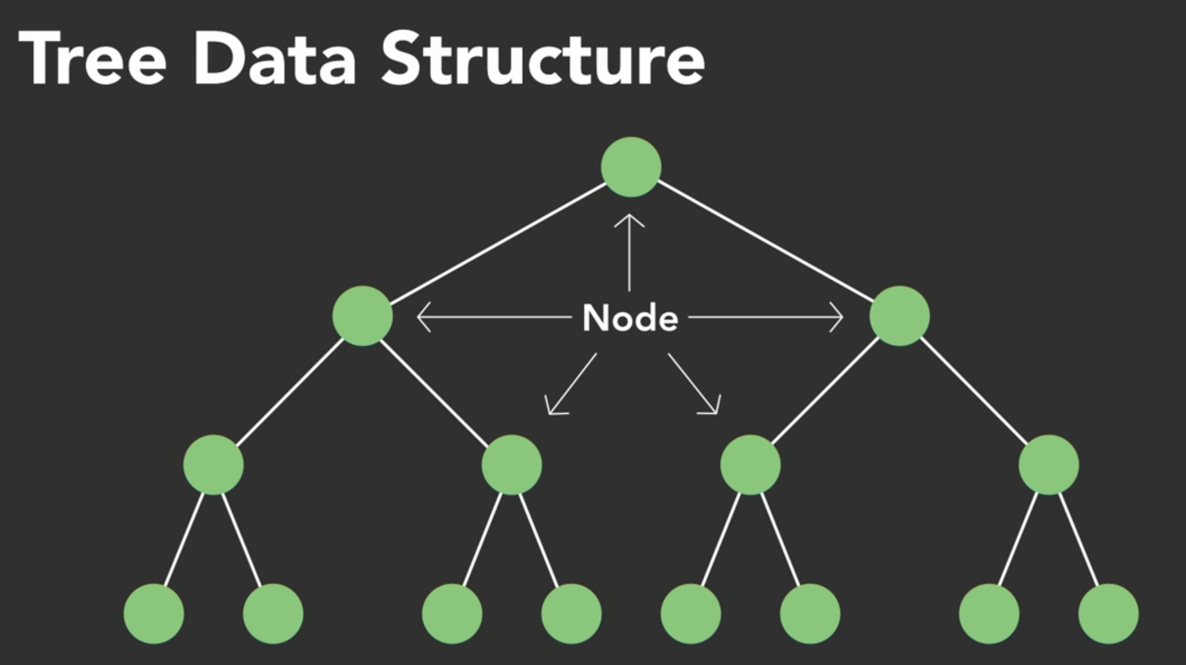

Comparison with Linked Lists:

Trees, like linked lists, consist of nodes.

The key distinction is that nodes in a tree can be linked to one, two, or more nodes, whereas linked lists primarily have nodes connected one after the other.

Logical Structure:

A tree is a logical data structure, representing an idea or concept.

It's not necessary to consider how nodes are physically allocated in memory; focus on the logical relationships between nodes.

Root Node:

Every tree has a starting point called the "root" node.

The root node can contain data and links to other nodes.

It serves as the topmost node in the tree.

Child Nodes:

Nodes linked directly from a parent node are referred to as "child" nodes.

The root node is the parent of its linked child nodes.

Hierarchy of Parents and Children:

The concept of parent and child nodes extends recursively through the tree structure.

A node can be both a parent (to its child nodes) and a child (of its parent node).

Specialized Type of Tree:

A linked list can be seen as a specialized type of tree structure where each node has only one link, leading to a child node.

Additional Terminology:

Nodes with the same parent are called "siblings."

Nodes with no children are termed "leaf nodes" or simply "leaves."

Variations with Constraints:

Trees can vary based on constraints imposed on their structure.

For example, a constraint might limit each node to having a maximum of two children.

The specific constraints applied can optimize the tree for various operations and functionality.

In summary, tree data structures consist of nodes linked hierarchically, starting from a root node. Nodes can have various numbers of children, and different constraints can be applied to create specialized tree structures with optimized characteristics for specific use cases.

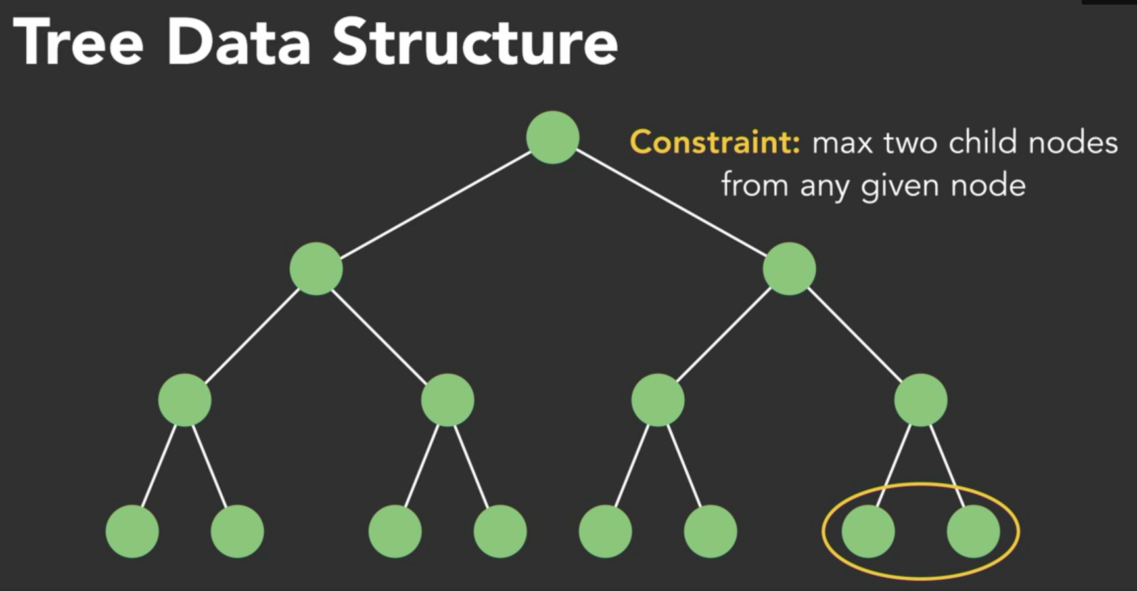

Understand binary search trees

Binary Tree Constraint:

A binary tree is a specialized type of tree in which each node has two immediate child nodes: a left child and a right child.

Binary Search Tree (BST):

A BST is a further specialized type of binary tree.

It imposes an order constraint, ensuring that the tree remains sorted.

Order Rule:

In a BST, a left child node must have a value less than its parent, while a right child node must have a value greater than its parent.

This rule holds recursively throughout the tree structure.

 A binary tree is a tree with two nodes. A binary search tree is also a tree with two nodes, but it has the additional constraint of how nodes are added. Nodes are added on the left if they are of lesser value than the root. Nodes are added on the right if they are of greater value than the root. With this, we are able to store elements in a given order so that when we do search for an item, it's much quicker - O(log(n)) time.

Sorting Data Structure:

BSTs naturally maintain sorted order without the need for extensive reorganization.

They are ideal for keeping data organized and sorted efficiently.

Use in Key-Value Pairs:

BSTs are often used to sort key-value pairs, where the key represents an object or data item.

The tree structure allows for quick sorting and retrieval of key-value pairs.

Insertion Example:

To build a BST, start with the root node.

Insert nodes by comparing their values to determine whether they become left or right child nodes based on the order rule.

Retrieval Example:

To retrieve a node in a BST, begin at the root node.

Compare the target value with the current node's value and follow the left or right child accordingly.

This process quickly narrows down the search path.

Balanced vs. Unbalanced Trees:

An unbalanced tree has more levels of nodes on one side than the other.

Unbalanced trees may require more operations for finding, inserting, or deleting values on the side with more levels.

Language Support:

Many programming languages use BSTs behind-the-scenes to implement data structures like sets or dictionaries.

C++ often uses BSTs to implement the set data structure.

While dictionaries are commonly implemented with hash tables, BSTs excel in maintaining sorted keys.

In summary, Binary Search Trees (BSTs) are specialized binary trees with an order rule that keeps them sorted. They are valuable for efficient sorting and retrieval of data and are commonly used as the underlying structure for implementing various data structures in programming languages.

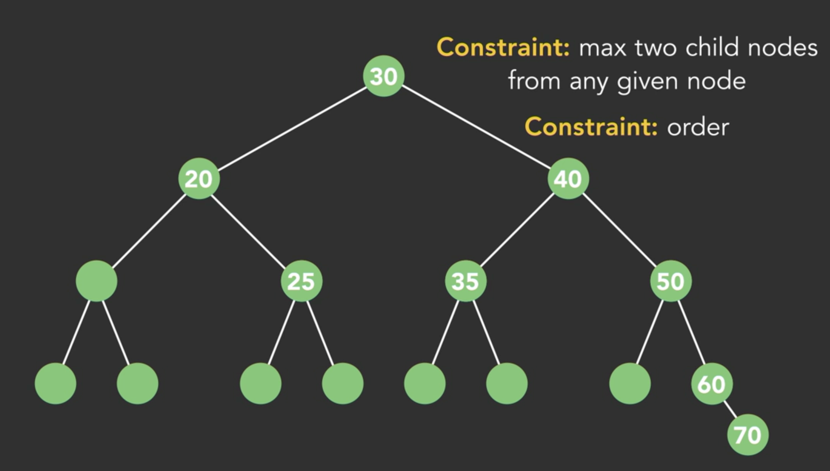

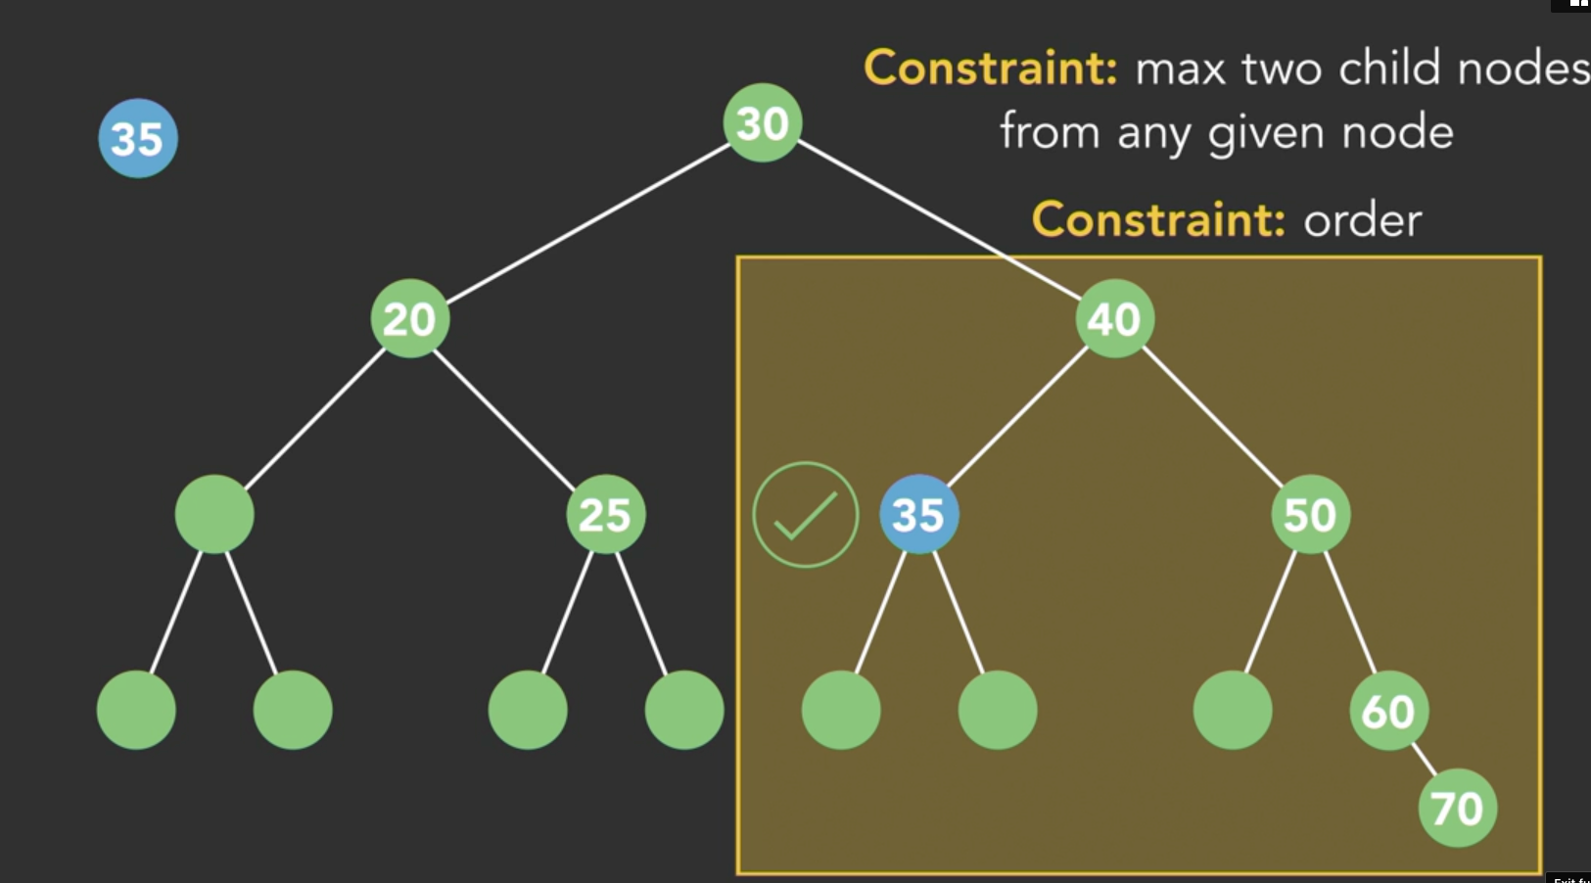

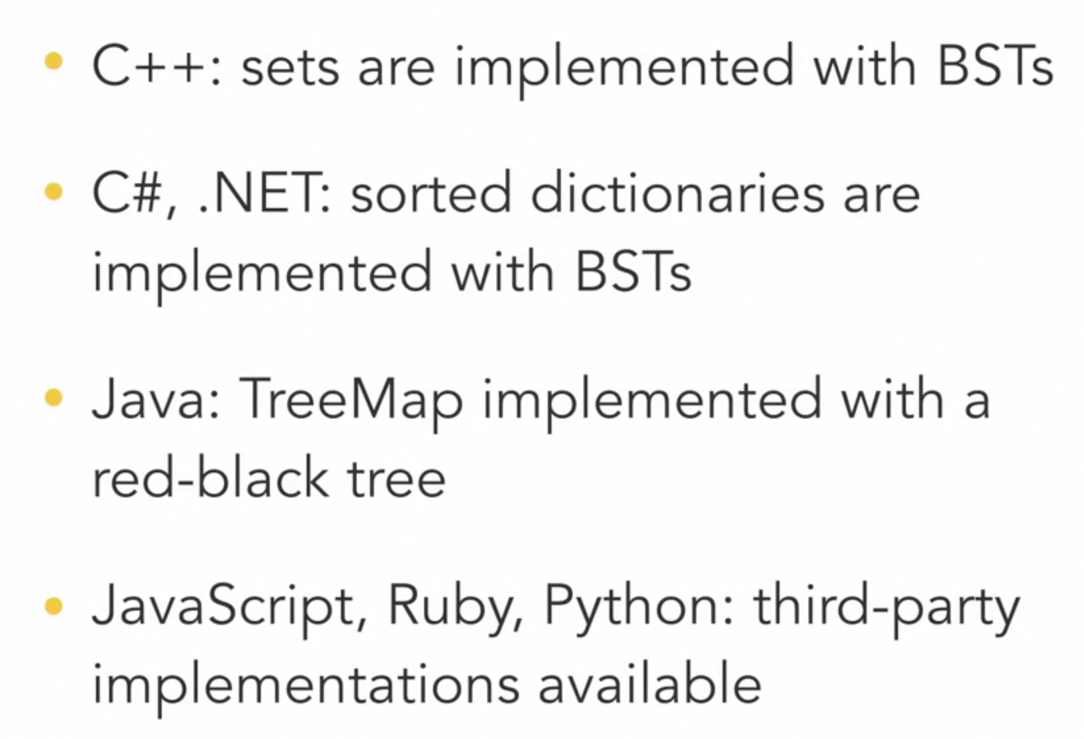

Heaps:

Heap as a Data Structure:

A heap is a specialized data structure implemented as a binary tree.

It imposes specific constraints on how data is organized.

Heap Basics:

Heaps are collections of objects where items are added from top to bottom, left to right, filling each level before moving to the next.

The tree structure remains balanced automatically.

Types of Heaps:

Two main types: Min Heap and Max Heap.

In a Min Heap, the root node always contains the smallest value in the heap.

In a Max Heap, the root node always contains the largest value.

Heap Constraints:

In a Min Heap, every child node must be greater than its parent node.

In a Max Heap, every child node must be less than its parent node.

Adding Elements:

When adding elements to a heap, they are placed in the next available slot.

A series of comparisons and swaps ensure the heap's order is maintained.

Heap Organization:

Heaps are not fully sorted data structures.

At any level beyond the root, values do not need to be in any specific order as long as they meet the heap's constraints.

Priority Queues:

Heaps are commonly used to implement priority queues.

Priority queues focus on the next item to be processed, allowing high-priority items to bubble to the top.

Specific Use Cases:

Heaps are well-suited for priority queues and certain sorting algorithms.

They excel when the focus is on quickly identifying the minimum or maximum value in a collection.

In summary, heaps are binary tree-based data structures with specialized constraints for maintaining order. They are particularly useful for implementing priority queues and specific sorting algorithms.

Heapify:

Binary Heap:

A binary heap is a complete binary tree where each node satisfies the heap property. In a min heap, every parent node has a value less than or equal to its children, while in a max heap, every parent node has a value greater than or equal to its children.

Let's consider a min heap for our examples.

Heapify:

Heapify is the process of ensuring that a binary tree satisfies the heap property. It's used to create a valid heap from an array of elements or to restore the heap property after an insertion or deletion operation.

Insertion:

When you insert a new element into a heap, you typically add it as the last element in the heap (at the bottom-right position). Then, you compare it with its parent and swap them if necessary until the heap property is satisfied.

Deletion (Extracting Minimum):

To remove the minimum element from a min heap (or maximum from a max heap), you first swap it with the last element in the heap (the bottom-right element). Then, you remove the last element and start a process called "heapify down" to ensure that the heap property is maintained. You compare the element with its children, swapping it with the smaller child (for a min heap) until it's in the correct position.

Let's illustrate these concepts with examples:

Starting with an unsorted array [9, 7, 6, 5, 2, 8], we apply heapify to create a min heap:

Initial Array:

markdown

Copy code

9

/ \

7 6

/ \ / \

5 2 8

After Heapify:

markdown

Copy code

2

/ \

5 6

/ \ / \

9 7 8

Now, the array [2, 5, 6, 9, 7, 8] represents a valid min heap.

Insertion Example:

Inserting the value 3 into the existing min heap [2, 5, 6, 9, 7, 8]:

Initial Min Heap:

markdown

Copy code

2

/ \

5 6

/ \ / \

9 7 8

After Inserting 3:

markdown

Copy code

2

/ \

3 6

/ \ / \

5 7 8 9

Now, the updated heap [2, 3, 6, 5, 7, 8, 9] maintains the min heap property.

Deletion (Extracting Minimum) Example:

Extracting the minimum value from the min heap [2, 3, 6, 5, 7, 8, 9]:

Initial Min Heap:

markdown

Copy code

2

/ \

3 6

/ \ / \

5 7 8 9

After Extracting Minimum (2):

markdown

Copy code

3

/ \

5 6

/ \ / \

9 7 8

Now, the minimum value (2) has been extracted, and the remaining elements [3, 5, 6, 9, 7, 8] still form a min heap.

Pros and Cons of all DS:

Sets:

Pros:

Ideal for checking the existence of values.

Ensures no duplicate values.

Optimized for membership tests.

Cons:

Limited functionality.

Not suitable for ordered data or complex operations.

Binary Search Trees (BST):

Pros:

Maintain sorted order.

Efficient for insertion, deletion, searching, and access.

Balanced BSTs offer O(log N) time complexity.

Cons:

Overhead in tree creation and management.

Unbalanced BSTs can degrade to O(N) time complexity.

Heaps:

Pros:

Excellent for priority queues.

Quick retrieval of minimum or maximum values.O(1)

Efficient insertion (O(log N)).

Cons:

Searching and deletion can be slow (O(N)).

No guaranteed specific order.

Some overhead due to element swapping during insertion.

These pros and cons summarize the key attributes of sets, binary search trees, and heaps as data structures.

. Every data structure has their pros and cons, and there is no perfect data structure. It all depends on what data you are trying to store, how you want to store it and how you want to access it.

Reffered {

<https://www.linkedin.com/learning/programming-foundations-data-structures-2019>

}